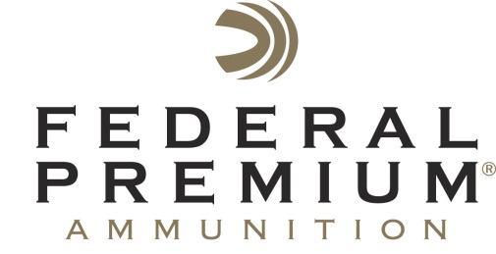
Contact: JJ Reich
Communications Manager
Shooting Sports
763-323-3862
FOR IMMEDIATE RELEASE E-mail: Vistapressroom@vistaoutdoor.com

Federal Premium to Introduce New Ammunition at 2017 NRA Annual Meetings and Exhibits Show

ANOKA, Minnesota – April 25, 2017 – Federal Premium Ammunition is proud to introduce a lineup of new high-performance products the 2017 NRA Meetings and Exhibits Show in Atlanta, Georgia, April 27-30. The introductions include Federal Premium Gold Medal Berger, Federal Premium Edge TLR, Federal Non-Typical and Federal Train + Protect. Attendees are encouraged to visit the Vista Outdoor booth no. 2542 during the show to see the entire new product lineup.

Unlike other so-called long-range projectiles that can fail to perform at lower velocities, the Federal Premium Edge TLR uses an exclusive Slipstream polymer tip to trigger expansion at extreme distances. On closer targets, the copper shank and bonded lead core retain weight for consistent, lethal penetration. Ballistics are likewise flawless. Credit the Edge TLR bullet’s sleek boat-tail design, secant ogive and unique AccuChannel grooving, which trim drag to an absolute minimum. Available in 308 Win., 30-06 Spring., 300 Win. Magnum and 300 Win. Short Magnum.

Elite long-range shooters will appreciate Federal Premium’s new Gold Medal Berger loads. The rounds feature a Berger bullet with high ballistic coefficient for flat trajectories, less wind drift and surgical long-range accuracy. Available in 223 Rem., 6.5 Grendel, 6.5 Creedmoor and 308 Win.

Federal Non-Typical centerfire rifle ammunition is designed specifically for diehard whitetail hunters. An optimized, soft-point bullet with concentric jacket provides tag-punching accuracy and lethal wound channels on any buck, anywhere, anytime.

Federal Train + Protect honors the American birthright to bear arms with a versatile hollow-point (VHP) design that delivers precise, practical performance at the range while ensuring instant, reliable expansion on impact. The result is the ideal combination for training as well as the freedom to defend yourself and your loved ones.

These products and many more can be viewed at the Vista Outdoor booth no. 2542 during the NRA Show.

Federal Premium is a brand of Vista Outdoor Inc., an outdoor sports and recreation company. For more information on Federal Premium, go to www.federalpremium.com.

About Vista Outdoor Inc.
Vista Outdoor is a leading global designer, manufacturer and marketer of consumer products in the growing outdoor sports and recreation markets. The company operates in two segments, Shooting Sports and Outdoor Products, and has a portfolio of well-recognized brands that provides consumers with a wide range of performance-driven, high-quality and innovative products for individual outdoor recreational pursuits. Vista Outdoor products are sold at leading retailers and distributors across North America and worldwide. Vista Outdoor is headquartered in Utah and has manufacturing operations and facilities in 13 U.S. States, Canada, Mexico and Puerto Rico along with international customer service, sales and sourcing operations in Asia, Australia, Canada, Europe and New Zealand. For news and information, visit www.vistaoutdoor.com or follow us on Twitter @VistaOutdoorInc and Facebook at www.facebook.com/vistaoutdoor.

