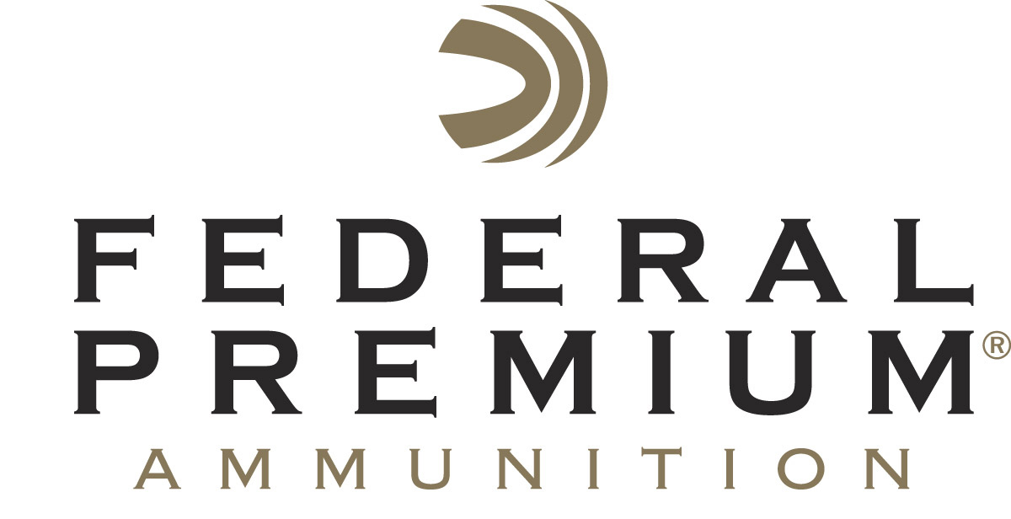
Contact: JJ Reich
Communications Manager
Firearms and Ammunition
(763) 323-3862
FOR IMMEDIATE RELEASE E-mail: pressroom@vistaoutdoor.com

Federal Premium to Host Hunting and Shooting Sports Celebrities at 2017 SHOT Show

ANOKA, Minnesota – January 11, 2017 – Federal Premium® Ammunition is pleased to invite attendees of the 2017 SHOT Show to the Vista Outdoor booth (14551) in Las Vegas, January 17-20. Show attendees will have the opportunity to meet professional shooter Julie Golob, popular online personalities Hickok45 and 22plinkster, and famed Second Amendment defender Colion Noir. In addition, Federal Premium will host Louisiana alligator hunters Troy and Jacob Landry.

Golob is a world champion shooter and author with a passion for the outdoors. She is the first and only woman to win U.S. national titles in all seven of practical shooting’s handgun divisions. She has more than 50 world and national titles and over 130 major championship titles to her credit. Golob will host product demonstrations from 10-11 a.m. on Tuesday and Thursday, January 17 and 19.

With more than 2.3 million subscribers to his YouTube channel and his popularity continuing to grow, Federal Premium ambassador Hickok45 is sure to draw a crowd when he signs autographs at the booth on Tuesday, January 17, from 12-2 p.m. Later that afternoon, YouTube trick shooter 22plinkster, whose downrange exploits and sage shooting advice have drawn nearly 44 million views, will sign autographs from 3-4 p.m.

Noir is a noted Second Amendment rights advocate and host of the National Rifle Association’s popular webshow “NOIR.” He is also an “NRATV” commentator, YouTube sensation, practicing attorney and avid shooter. Noir will host a question-and-answer session from 4-5 p.m. on Wednesday, January 18.

Troy and Jacob Landry, from the “Swamp People” series on History, will sign autographs from 3-4 p.m. on Wednesday, January 18 and return to the booth to discuss the wild world of Louisiana alligator hunting in a question-and-answer session from 3-4 p.m. on Thursday, January 19.

SHOT Show attendees are encouraged to stop by the Vista Outdoor booth (14551) to visit with these celebrities and learn more about the latest products offered by Federal Premium.

Federal Premium is a brand of Vista Outdoor Inc., an outdoor sports and recreation company. For more information on Federal Premium, go to www.federalpremium.com.

About Vista Outdoor Inc.
Vista Outdoor is a leading global designer, manufacturer and marketer of consumer products in the growing outdoor sports and recreation markets. The company operates in two segments, Shooting Sports and Outdoor Products, and has a portfolio of well-recognized brands that provides consumers with a wide range of performance-driven, high-quality and innovative products for individual outdoor recreational pursuits. Vista Outdoor products are sold at leading retailers and distributors across North America and worldwide. Vista Outdoor is headquartered in Utah and has manufacturing operations and facilities in 13 U.S. States, Canada, Mexico and Puerto Rico along with international customer service, sales and sourcing operations in Asia, Australia, Canada, Europe and New Zealand. For news and information, visit www.vistaoutdoor.com or follow us on Twitter @VistaOutdoorInc and Facebook at www.facebook.com/vistaoutdoor.

