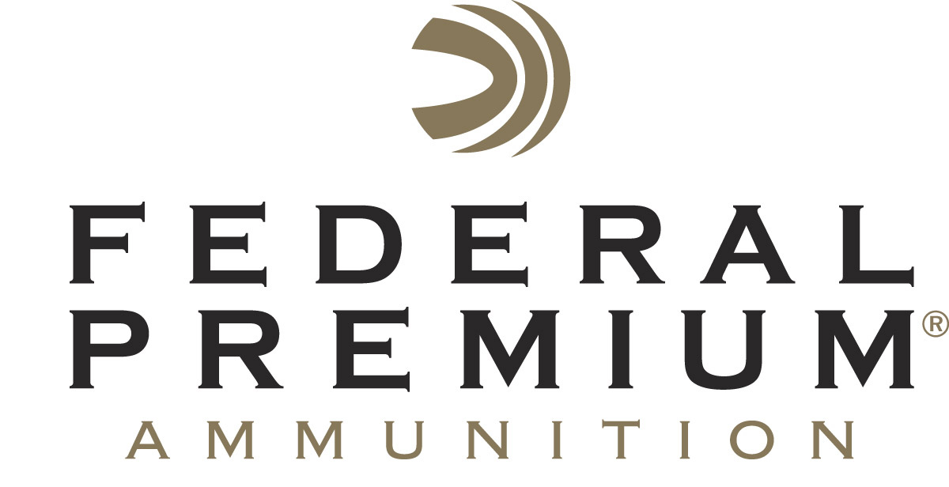
Contact: JJ Reich
Communications Manager
Firearms and Ammunition
(763) 323-3862
FOR IMMEDIATE RELEASE E-mail: pressroom@vistaoutdoor.com

NRA Shooting Illustrated Magazine Honors
Federal American Eagle Syntech with “2017 Ammunition Product of the Year” Golden Bullseye Award

ANOKA, Minnesota – February 8, 2017 – The National Rifle Association’s (NRA) Shooting Illustrated magazine has recognized Federal American Eagle Syntech with the Golden Bullseye Award for 2017 Ammunition Product of the Year. Federal Ammunition representatives will accept the prestigious honor Friday, April 28, during the 2017 NRA Annual Meetings & Exhibits in Atlanta, Georgia.

Shooting Illustrated is the NRA's newest official journal with a focus on concealed carry, self-defense and tactical shooting. Golden Bullseye Awards acknowledge the finest products available in the shooting sports.

“We are pleased to announce the winners of the 2017 Golden Bullseye Awards,” said Doug Hamlin, executive director of NRA Publications. “This year's winners exemplify what NRA members want in their shooting and hunting equipment—outstanding performance, innovative design and value. We congratulate those who have created the industry’s best new products.”

To qualify for consideration for a Golden Bullseye Award, the product must meet a variety of demanding criteria on design, function, value and overall contribution to the shooting industry. The product must also demonstrate extreme reliability and exceed evaluators’ expectations in rigorous field testing.

American Eagle Syntech offers target shooters the most advanced range ammunition available and allows handgun owners to protect their investment from the inside out. Syntech is the first range-specific ammunition designed to reduce fouling and extend barrel life with a high-tech polymer bullet coating. Combined with specialized clean-burning powders, Syntech ensures guns stay cleaner, longer, so enthusiasts can shoot more—and shoot better.

Additional benefits of the Syntech system include less perceived recoil and exclusive Catalyst™ primer, which provides the most reliable, consistent ignition possible. The absence of a copper jacket also minimizes splash-back on steel targets, making Syntech loads the perfect choice for target practice or competition.

American Eagle Syntech is available in 115-grain 9mm Luger, 165-grain 40 S&W and 230-grain 45 Auto.

Federal Premium is a brand of Vista Outdoor Inc., an outdoor sports and recreation company. For more information on Federal Premium, go to www.federalpremium.com.

About Vista Outdoor Inc.
Vista Outdoor is a leading global designer, manufacturer and marketer of consumer products in the growing outdoor sports and recreation markets. The company operates in two segments, Shooting Sports and Outdoor Products, and has a portfolio of well-recognized brands that provides consumers with a wide range of performance-driven, high-quality and innovative products for individual outdoor recreational pursuits. Vista Outdoor products are sold at leading retailers and distributors across North America and worldwide. Vista Outdoor is headquartered in Utah and has manufacturing operations and facilities in 13 U.S. States, Canada, Mexico and Puerto Rico along with international customer service, sales and sourcing operations in Asia, Australia, Canada, Europe and New Zealand. For news and information, visit www.vistaoutdoor.com or follow us on Twitter @VistaOutdoorInc and Facebook at www.facebook.com/vistaoutdoor.

###

