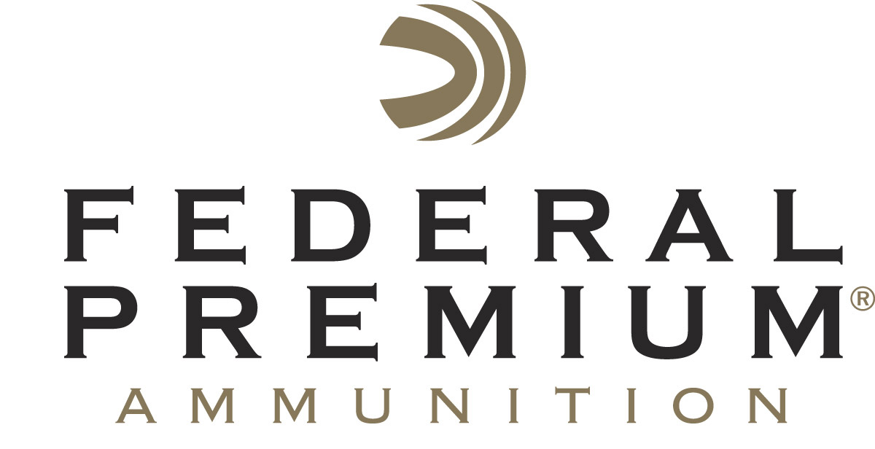
Contact: JJ Reich
Communications Manager
Firearms and Ammunition
(763) 323-3862
FOR IMMEDIATE RELEASE E-mail: pressroom@vistaoutdoor.com

Federal American Eagle Syntech Wins
“Ammunition of the Year” Industry Choice Award

ANOKA, Minnesota – August 9, 2017 – Federal American Eagle Syntech received the prestigious Ammunition of the Year award at the 2nd Annual 2017 Firearms Industry Choice Awards, July 22 at the Sloan Convention Center in Bowling Green, Kentucky.

The selection process, conducted at the Rockcastle Shooting Center in Park City, Kentucky, includes hands-on, unbiased, multi-day testing and evaluation by a mix of firearms retailers, distributors, professional shooters, gunsmiths, law enforcement and military personnel, members of the outdoor media and recreational shooters.

"It's an honor to win Ammunition of the Year from this balanced group of evaluators. The team at Federal is thrilled that the judges share our excitement, and that of all who shoot it, about Syntech,” said Federal Premium Handgun Ammunition GPL Director Jason Nash.

Product categories for evaluation included rifle, handgun, shotgun, optic, accessory and ammunition. Manufacturers are encouraged to submit what they consider to be their finest product, to be evaluated for fit, form, finish and functionality.

“Recognizing innovation and creativity in new product development by exceptional companies in our industry is important,” said Rockcastle CEO Nick Noble. “The awards represent a new way to answer the age-old question of which industry manufacturer produces the best products.”

Syntech loads tested included the 115-grain 9mm Luger, 165-grain 40 S&W and 230-grain 45 Auto. Evaluators’ overwhelming high marks were punctuated with personal comments including, “excellent, very consistent and great product!”

American Eagle Syntech was introduced in 2016, offering target shooters the most advanced range ammunition available and allowing handgun owners to protect their investment from the inside out. Syntech is the first range-specific ammunition designed to reduce fouling and extend barrel life with a high-tech polymer bullet coating. Combined with specialized clean-burning powders, Syntech ensures guns stay cleaner, longer, so enthusiasts can shoot more—and shoot better.

Additional benefits of the Syntech system include less perceived recoil and the exclusive Catalyst primer, which provides the most reliable, consistent ignition possible. The absence of a copper jacket also minimizes splash-back on steel targets, making Syntech loads the perfect choice for target practice or competition.

Federal Premium is a brand of Vista Outdoor Inc., an outdoor sports and recreation company. For more information on Federal Premium, go to www.federalpremium.com.

About Vista Outdoor
Vista Outdoor is a leading global designer, manufacturer and marketer of consumer products in the growing outdoor sports and recreation markets. The company operates in two segments, Shooting Sports and Outdoor Products, and has a portfolio of well-recognized brands that provides consumers with a wide range of performance-driven, high-quality and innovative products for individual outdoor recreational pursuits. Vista Outdoor products are sold at leading retailers and distributors across North America and worldwide. Vista Outdoor is headquartered in Utah and has manufacturing operations and facilities in 13 U.S. States, Canada, Mexico and Puerto Rico along with international customer service, sales and sourcing operations in Asia, Australia, Canada, and Europe. For news and information, visit www.vistaoutdoor.com or follow us on Twitter @VistaOutdoorInc and Facebook at www.facebook.com/vistaoutdoor.

###

