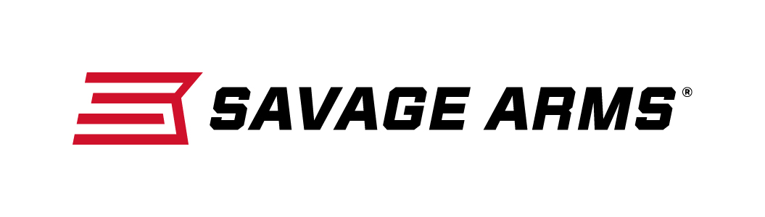
Contact: JJ Reich
Communications Manager
Firearms and Ammunition
(763) 323-3862
FOR IMMEDIATE RELEASE E-mail: pressroom@vistaoutdoor.com

Savage Introduces the 10/110 Stealth Evolution in Six Popular Calibers and Left-Hand Models

Westfield, Massachusetts – September 29, 2017 – Savage is pleased to introduce the 10/110 Stealth Evolution chassis rifle chambered in six popular long-range calibers, including the all-new 6mm Creedmoor. The rifle boasts exceptional accuracy and performance, and it is available in both right-hand and left-hand models. Shipments are currently being delivered to dealers.

The 10/110 Stealth Evolution blends pinpoint precision and torture-tested toughness to beat the most challenging targets and conditions. It pairs a heavy fluted barrel with a monolithic aluminum chassis finished in rugged bronze Cerakote. The incredibly hard polymer-ceramic coating greatly enhances resistance to abrasion, corrosion and impact.

Its factory-blueprinted 10/110 action, matched with Savage’s zero-tolerance headspacing, user-adjustable AccuTrigger and 5R button rifling, produces sub-MOA accuracy at extreme range, right out of the box.

Features & Benefits
- Factory blueprinted Savage 10/110 action
- Monolithic aluminum chassis, machined from billet
- Full-length top-rail
- Bronze Cerakote finish
- Magpul PRS Gen3 adjustable buttstock
- User-adjustable AccuTrigger
- Heavy fluted barrel with muzzle brake
- Detachable box magazine
- 5R rifling

Part No. / Description / MSRP
22859 / 10 Stealth Evolution 223 Rem. / $1,799
22865 / 10 Stealth Evolution (LH) 223 Rem. / $1,799
22862 / 10 Stealth Evolution 6mm Creedmoor / $1,799
22868 / 10 Stealth Evolution (LH) 6mm Creedmoor / $1,799
22861 / 10 Stealth Evolution 6.5 Creedmoor / $1,799
22867 / 10 Stealth Evolution (LH) 6.5 Creedmoor / $1,799
22860 / 10 Stealth Evolution 308 Win. / $1,799
22866 / 10 Stealth Evolution (LH) 308 Win. / $1,799
22863 / 110 Stealth Evolution 300 Win. Magnum / $1,999
22869 / 110 Stealth Evolution (LH) 300 Win. Magnum / $1,999
22864 / 110 Stealth Evolution 338 Lapua Magnum / $2,149
22870 / 110 Stealth Evolution (LH) 338 Lapua Magnum / $2,149
Savage Arms is a brand of Vista Outdoor Inc., an outdoor sports and recreation company. To learn more about Savage Arms, visit www.savagearms.com.
.
About Vista Outdoor
Vista Outdoor is a leading global designer, manufacturer and marketer of consumer products in the growing outdoor sports and recreation markets. The company operates in two segments, Shooting Sports and Outdoor Products, and has a portfolio of well-recognized brands that provides consumers with a wide range of performance-driven, high-quality and innovative products for individual outdoor recreational pursuits. Vista Outdoor products are sold at leading retailers and distributors across North America and worldwide. Vista Outdoor is headquartered in Utah and has manufacturing operations and facilities in 13 U.S. States, Canada, Mexico and Puerto Rico along with international customer service, sales and sourcing operations in Asia, Australia, Canada, and Europe. For news and information, visit www.vistaoutdoor.com or follow us on Twitter @VistaOutdoorInc and Facebook at www.facebook.com/vistaoutdoor.

###

