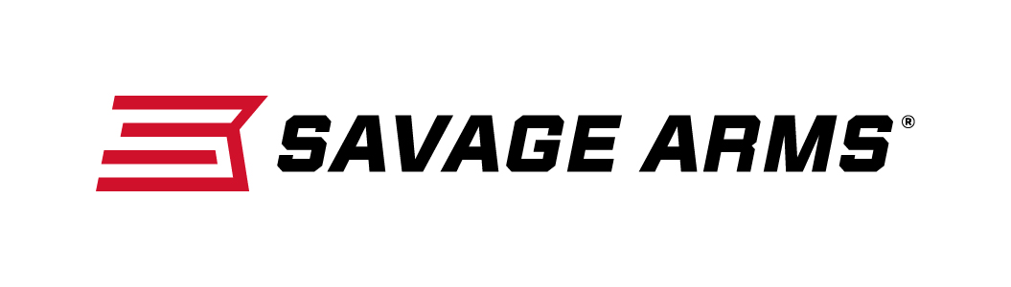
Contact: JJ Reich
Communications Manager
Firearms and Ammunition
(763) 323-3862
FOR IMMEDIATE RELEASE E-mail: pressroom@vistaoutdoor.com

Savage Arms B17 17 HMR Wins Outdoor Life Great Buy Award

SUFFIELD, Connecticut – May 16, 2017 – Savage Arms' new B17 17 HMR bolt-action recently earned a Great Buy award in Outdoor Life magazine's 2017 Gun & Optics Test. The award was presented to the Savage Arms team during the 2017 NRA Meetings & Exhibits in Atlanta, Georgia, on April 27.

“This rifle is smooth, slick and easy to load and shoot. It turned in some really good accuracy," said Outdoor Life Senior Deputy Editor John Snow. "For the price of $329, this is one of the best buys of the year, there is no doubt about it. If you are looking for a 17 HMR plinker that will put a smile on your face, this is the gun that will do it."

Savage introduced the B17, B22 and B22 Magnum bolt-action rimfire rifles in December of 2016. This lineup includes 12 options priced from $281 to $413. The B-Series’ ergonomically designed stock, higher comb, top tang safety and target-style, vertical pistol grip allow shooters to hold the rifle in a more natural position that puts less pressure on the wrist.

The B Series includes a dozen new models in configurations including Sporter Barrel, Heavy Barrel, Heavy Threaded (suppressor ready) and Heavy Stainless. Like the popular A Series rimfires, all B Series rifles feature a 10-round rotary magazine and the accuracy-boosting adjustable AccuTrigger.

An Outdoor Life social media video on the award-winning rifle can be viewed at: https://www.facebook.com/outdoorlife/videos/10154324629911021/

Savage Arms is a brand of Vista Outdoor Inc., an outdoor sports and recreation company. To learn more about Savage Arms, visit www.savagearms.com.

Photo (left to right): Al Kasper (Savage Arms), John Snow (Outdoor Life) and Bill Dermody (Savage Arms).

About Vista Outdoor
Vista Outdoor is a leading global designer, manufacturer and marketer of consumer products in the growing outdoor sports and recreation markets. The company operates in two segments, Shooting Sports and Outdoor Products, and has a portfolio of well-recognized brands that provides consumers with a wide range of performance-driven, high-quality and innovative products for individual outdoor recreational pursuits. Vista Outdoor products are sold at leading retailers and distributors across North America and worldwide. Vista Outdoor is headquartered in Utah and has manufacturing operations and facilities in 13 U.S. States, Canada, Mexico and Puerto Rico along with international customer service, sales and sourcing operations in Asia, Australia, Canada, and Europe. For news and information, visit www.vistaoutdoor.com or follow us on Twitter @VistaOutdoorInc and Facebook at www.facebook.com/vistaoutdoor.

###

