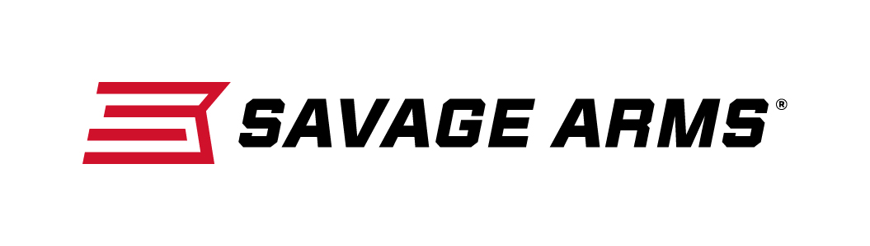
Contact: JJ Reich
Communications Manager
Firearms and Ammunition
(763) 323-3862
FOR IMMEDIATE RELEASE E-mail: pressroom@vistaoutdoor.com

Savage Arms Expands BA Stealth Chassis Rifle Lineup with New
Left-Hand Models and 223 Rem. Chambering

Westfield, Massachusetts – August 29, 2017 – Savage Arms is pleased to announce left-hand versions of its popular Stealth chassis rifle chambered in popular long-range calibers. The lineup has also expanded to include 223 Rem. The proven rifle platform delivers exceptional accuracy and performance. Shipments are currently being delivered to dealers.

The Model 10/110 BA Stealth is a lighter, more compact option in the BA line. It features a factory-blueprinted Model 10/110 barreled action mated to a custom version of the Drake Hunter/Stalker monolithic chassis, which has been modified to Savage’s specifications.

Features & Benefits
- New left-hand and 223 Rem. models
- Factory-blueprinted Savage action
- Monolithic chassis machined from a solid billet of aluminum
- M-LOK fore-end and Picatinny rail for easy configuration
- Adjustable AccuTrigger
- 5/8 x 24 threaded muzzle with protector
- EGW one-piece scope rail
- Fab Defense GL-SHOCK six-position, shock-absorbing buttstock with adjustable cheek

Part No. / Description / MSRP
22639 / 110 BA Stealth, 300 Win. Mag. / $1484
22664 / 110 BA Stealth 300 Win. Mag. Left Hand / $1484 - NEW
22640 / 110 BA Stealth 338 Lapua Mag. / $1622
22665 / 110 BA Stealth 338 Lapua Mag. Left Hand / $1622 - NEW
22847 / 10 BA Stealth 223 Rem. / $1207 - NEW
22848 / 10 BA Stealth 223 Rem. Left Hand / $1207 - NEW
22637 / 10 BA Stealth 308 Win. / $1207
22662 / 10 BA Stealth 308 Win. Left Hand / $1207 - NEW
22638 / 10 BA Stealth 6.5 Creedmoor / $1207
22663 / 10 BA Stealth 6.5 Creedmoor Left Hand / $1207 - NEW

Savage Arms is a brand of Vista Outdoor Inc., an outdoor sports and recreation company. To learn more about Savage Arms, visit www.savagearms.com.

About Vista Outdoor
Vista Outdoor is a leading global designer, manufacturer and marketer of consumer products in the growing outdoor sports and recreation markets. The company operates in two segments, Shooting Sports and Outdoor Products, and has a portfolio of well-recognized brands that provides consumers with a wide range of performance-driven, high-quality and innovative products for individual outdoor recreational pursuits. Vista Outdoor products are sold at leading retailers and distributors across North America and worldwide. Vista Outdoor is headquartered in Utah and has manufacturing operations and facilities in 13 U.S. States, Canada, Mexico and Puerto Rico along with international customer service, sales and sourcing operations in Asia, Australia, Canada, and Europe. For news and information, visit www.vistaoutdoor.com or follow us on Twitter @VistaOutdoorInc and Facebook at www.facebook.com/vistaoutdoor.

###

