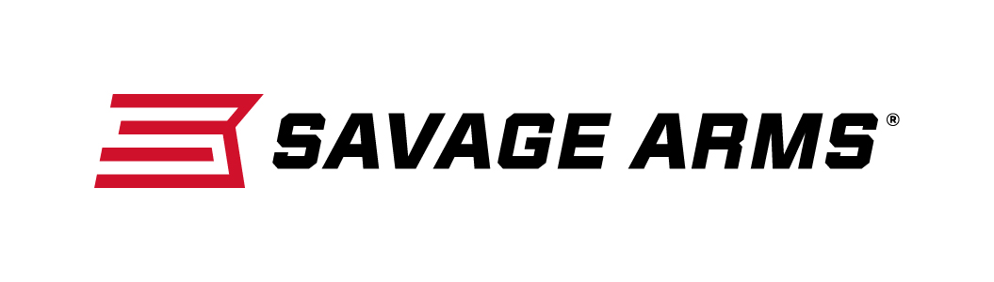

Contact: JJ Reich
Communications Manager
Firearms and Ammunition
(763) 323-3862
FOR IMMEDIATE RELEASE E-mail: pressroom@vistaoutdoor.com

Savage Arms Announced as Official Shooting Sports
Partner of the Boy Scouts of America

Savage Arms Support Scouting and Youth Shooting Sports Programs

SUFFIELD, Connecticut – July 27, 2017 – Savage Arms is now one of the official shooting sports partners of the Boy Scouts of America. The rifle partnership supports 1,620 Scout Camps that offer shooting sports across the country. The brand is also the exclusive firearm sponsors at the Summit Bechtel Family National Scout Reserve, home of the Boy Scouts National Jamboree and high adventure courses.

“Savage is proud to be the Official Shooting Sports Partner of the Boy Scouts of America,” said Beth Shimanski, Senior Marketing Manager for Savage Arms. “We know that when youth learn proper firearms safety at a young age, it can grow into a lifelong passion. We are thrilled to be supporting the future of our shooting and hunting sports with this great organization.”

The Summit Bechtel Reserve is the permanent home of the 2017 Boy Scouts National Jamboree, which runs July 19 to 28 this year. The event attracts 40,000 Scouts and instructors from across the country. The 10,600-acre property is also home to Barrels Shooting Range, presented by Savage Arms, which has 233 individual Shooting Stations across the facility. Savage Arms rimfire and centerfire rifles fueled the shooting-sports action at the 2017 Jamboree, which included Savage Mark II FXP 22 LR, Savage II XP .308 Win. and Savage II XP .223 Rem. model rifles.

For more than 100 years, Boy Scouts of America has helped build future leaders by combining educational activities and lifelong values with fun. Throughout the BSA, all program divisions use responsible outdoor activities to promote character development and values-based leadership. Shooting sports, such as archery, have the ability to attract and retain youth. More than 2 million shooting sports and archery merit badges are earned by Scouts, with an estimated 18 million rounds of ammunition shot annually by Scouts. For more information on the Summit Bechtel Reserve, the Boy Scouts of America, and “The Marksman” summer adventure courses, visit www.summitbsa.org

Savage Arms is a brand of Vista Outdoor Inc., an outdoor sports and recreation company. To learn more about Savage Arms, visit www.savagearms.com.

About Vista Outdoor
Vista Outdoor is a leading global designer, manufacturer and marketer of consumer products in the growing outdoor sports and recreation markets. The company operates in two segments, Shooting Sports and Outdoor Products, and has a portfolio of well-recognized brands that provides consumers with a wide range of performance-driven, high-quality and innovative products for individual outdoor recreational pursuits. Vista Outdoor products are sold at leading retailers and distributors across North America and worldwide. Vista Outdoor is headquartered in Utah and has manufacturing operations and facilities in 13 U.S. States, Canada, Mexico and Puerto Rico along with international customer service, sales and sourcing operations in Asia, Australia, Canada, and Europe. For news and information, visit www.vistaoutdoor.com or follow us on Twitter @VistaOutdoorInc and Facebook at www.facebook.com/vistaoutdoor.

###

