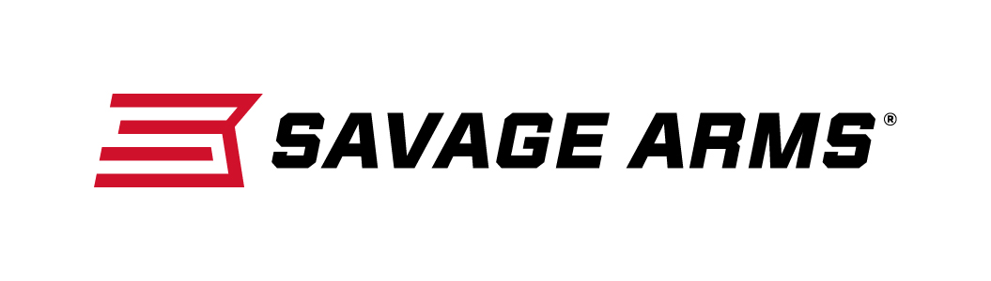
Contact: JJ Reich
Communications Manager
Firearms and Ammunition
(763) 323-3862
FOR IMMEDIATE RELEASE E-mail: pressroom@vistaoutdoor.com

Savage Arms MSR 15 Recon and MSR 15 Patrol Deliver Upgraded Performance as Standard Features

SUFFIELD, Connecticut – February 3, 2017 – Savage Arms recently announced two models of semi-automatic Modern Sporting Rifles to its popular lineup of high-performance firearms. On the AR-15 platform, the new MSR 15 Recon and MSR 15 Patrol are chambered in 223 Wylde, which enhances out-of-the-box accuracy and allows safe, reliable function with both 223 Rem. and 5.56x45mm ammunition. Both rifles redefine the category with the kind of tack-driving precision and seamless performance you’d expect from a Savage. Shipments are currently being delivered to dealers.

Savage’s new MSR 15 Recon comes standard with upgrades serious shooters demand, including a BLACKHAWK! AR Blaze trigger, free-float handguard and upgraded Savage barrel with a 223 Wylde target chamber. Its 5R rifling and a Melonite QPQ finish ensure the most consistent, accurate performance in any conditions, while the Recon’s custom-forged lower receiver and BLACKHAWK! adjustable buttstock and pistol grip impart a look that stands out from the crowd.

Features:
- Custom forged lower receiver for unique look
- Melonite QPQ 16 1/8-inch barrel with 5R rifling
- 223 Wylde target chamber for use with 223 Rem. or 5.56x45mm
- BLACKHAWK! AR Blaze trigger
- Mid-length gas system
- Free-float M-LOK handguard
- BLACKHAWK! KNOXX AR Pistol Grip and AXIOM Carbine Stock
- BLACKHAWK! flip-up sights

The new Savage MSR 15 Patrol is a step up from the many rack-grade M4 clones popular today. With an upgraded barrel featuring a 223 Wylde target chamber, 5R rifling and a Melonite QPQ finish, the rifle delivers accuracy well beyond mil-spec. A BLACKHAWK! handguard, pistol grip and adjustable buttstock further separate the Patrol from all other MSRs.

Features:
- Mil-spec upper and lower receiver
- 16 1/8-inch barrel with 5R rifling and Melonite QPQ finish
- 223 Wylde target chamber for use with 223 Rem. or 5.56x45mm
- Mil-spec trigger
- Mid-length gas system
- BLACKHAWK! KNOXX AR Pistol Grip and AXIOM Carbine Stock
- Custom A-frame gas block front sight
- BLACKHAWK! flip-up rear sight

To learn more about Savage Arms and its new line of MSRs, visit www.savagearms.com/msr.

Part No. / Description / MSRP
22901 / MSR 15 Recon 223 Rem.-5.56x45mm / $999
22900 / MSR 15 Patrol 223 Rem.-5.56x45mm / $852

About Savage Arms
Headquartered in Westfield, Massachusetts for more than 100 years, Savage Arms is one of the world's largest manufacturers of hunting, competition and self-defense centerfire and rimfire rifles, and shotguns. Their firearms are best known for accuracy and value. The entrepreneurial spirit that originally defined the company is still evident in its ongoing focus on continuous innovations, craftsmanship, quality and service.

###

