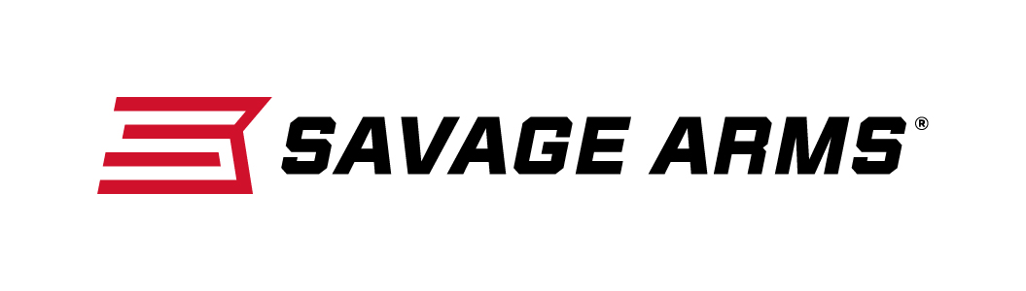
Contact: JJ Reich
Communications Manager
Firearms and Ammunition
(763) 323-3862
FOR IMMEDIATE RELEASE E-mail: pressroom@vistaoutdoor.com

Savage Arms MSR-10 Hunter Delivers Accurate Performance, Enhanced Features and Lightweight Design

Westfield, Massachusetts – December 4, 2017 – Savage Arms has great news for serious shooters and hunters who want more from their modern sporting rifles. Several options of the semi-auto MSR 10 Hunter takes the popular AR-10 platform to new heights, offering greater performance, expanded caliber choices and a modern design, plus a full suite of custom upgrades packaged as standard features. Shipments of the new rifles have been delivered to dealers.

The Savage MSR 10 Hunter is a compact sporting platform that still packs the punch of 308 Win., and 6.5 Creedmoor chamberings. The rifle squeezes even more performance from its upgraded Savage barrel with a 5R rifling, a BLACKHAWK!® trigger with nickel boron treatment, and a tough Melonite QPQ finish. Other upgrades including a freefloat fore-end, custom-forged lower receiver and BLACKHAWK! adjustable buttstock and pistol grip turn the Hunter into the ultimate big game rifle.

Features & Benefits
- Compact AR-10 design
- 308 Win. (1:10-inch, 5R Right-hand Rifling) and 6.5 Creedmoor (1:8-inch, 5R Right-hand Rifling)
- 16 1/8-inch fluted barrel with Melonite QPQ finish (308 Win.); 18-inch barrel for 6.5 Creedmoor
- 7.8 pounds, 308 Win; 8.0 pounds, 6.5 Creedmoor
- Custom forged upper/lower for unique look and compact size
- Free-float M-LOK handguard
- BLACKHAWK! KNOXX AR Pistol Grip and AXIOM Carbine Stock
- BLACKHAWK! trigger with nickel boron treatment

In January 2018, MSR 10 Hunter will available in the 338 Federal chambering. Since its introduction in 2006, the 338 Federal has established itself has an extremely versatile, high-performance big game cartridge.

Built on the .308 case and “necked-up” to hold a .338 diameter bullet, this 338 Federal load offers hunters a faster muzzle velocity than the 308 Win. But with a heavier bullet. As a result, the short-action cartridge provides magnum energy for devastating performance on game, without magnum recoil.

Part No. / Description / MSRP
22902 / MSR 10 Hunter, 308 Win. / $1,481
22903 / MSR 10 Hunter, 6.5 Creedmoor / $1,481
22902 / MSR 10 Hunter, 338 Federal / $1,481

To learn more about Savage Arms, visit www.savagearms.com.

About Savage Arms
Headquartered in Westfield, Massachusetts for more than 100 years, Savage Arms is one of the world's largest manufacturers of hunting, competition and self-defense centerfire and rimfire rifles, and shotguns. Their firearms are best known for accuracy and value. The entrepreneurial spirit that originally defined the company is still evident in its ongoing focus on continuous innovations, craftsmanship, quality and service.

###

