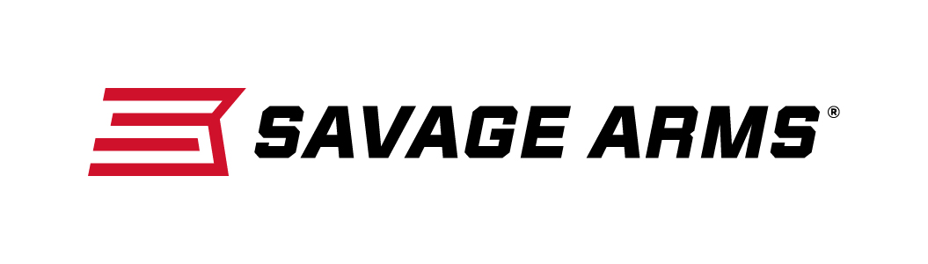
Contact: JJ Reich
Communications Manager
Firearms and Ammunition
(763) 323-3862
FOR IMMEDIATE RELEASE E-mail: pressroom@vistaoutdoor.com

Savage MSR 10 Long Range Is Loaded With Upgrades Packaged as Standard Features

Westfield, Massachusetts – December 5, 2017 – Savage Arms has great news for serious shooters who want more from their modern sporting rifles. Its semi-automatic MSR 10 Long Range takes the popular AR-10 platform to new heights, offering greater performance, expanded caliber choices and a modern design, plus a full suite of custom upgrades packaged as standard features. Shipments of the new rifle have been delivered to dealers.

Initially chambered in 6.5 Creedmoor and 308 Win., the MSR 10 Long Range is built on a compact frame with a non-reciprocating side-charging handle. Its BLACKHAWK! two-stage target trigger with nickel boron treatment and Magpul PRS adjustable buttstock optimize the inherent accuracy of the upgraded Savage barrel, which features 5R rifling and a Melonite QPQ finish.

Features & Benefits
- Compact AR-10 design
- Non-reciprocating side charging handle
- 308 Win. (1:10-inch 5R Right-hand Rifling) and 6.5 Creedmoor (1:8-inch Right-hand Rifling)
- Fluted heavy barrel with Melonite QPQ finish
- 9.75 pounds, 308 Win.; 10.0 pounds, 6.5 Creedmoor
- Custom forged upper/lower for unique look and compact size
- Free-float M-LOK rail
- Magpul PRS Gen3 buttstock
- BLACKHAWK! KNOXX AR Pistol Grip
- BLACKHAWK! two-stage target trigger with nickel boron treatment

In January 2018, MSR 10 Long Range will be available in the 6mm Creedmoor chambering.

Built on the 6.5 Creedmoor case and “necked-down” to hold a .243 diameter bullet, this round shoots fast and flat. The case design allows room for long, heavy bullets while still functioning in short action rifles. It is popular with long-range precision match shooters. Further and the round doesn’t beat up its shooter with recoil.

Description / MSRP
MSR 10 Long Range, 308 Win. / $2,284
MSR 10 Long Range, 6.5 Creedmoor / $2,284
MSR 10 Long Range, 6mm Creedmoor / $2,284

To learn more about Savage Arms, visit www.savagearms.com.

About Savage Arms
Headquartered in Westfield, Massachusetts for more than 100 years, Savage Arms is one of the world's largest manufacturers of hunting, competition and self-defense centerfire and rimfire rifles, and shotguns. Their firearms are best known for accuracy and value. The entrepreneurial spirit that originally defined the company is still evident in its ongoing focus on continuous innovations, craftsmanship, quality and service.

###

