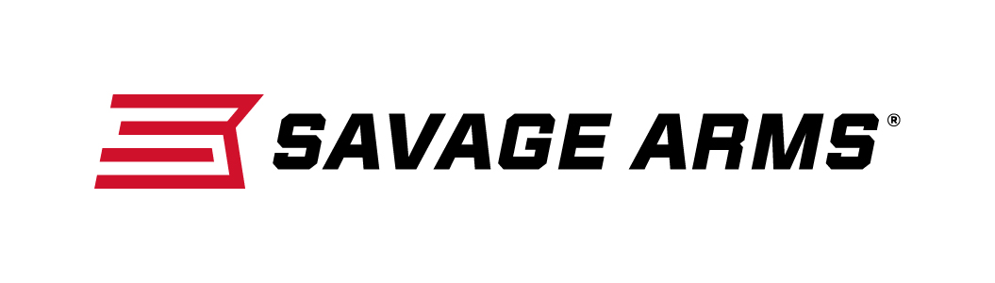
Contact: JJ Reich
Communications Manager
Firearms and Ammunition
(763) 323-3862
FOR IMMEDIATE RELEASE E-mail: pressroom@vistaoutdoor.com

Savage Arms Signs Champion Shooter and Veteran Outdoor Communicator Patrick Kelley as Brand Ambassador

SUFFIELD, Connecticut – April 20, 2017 – Savage Arms is proud to announce champion shooter, trusted outdoor communicator and noted competitive shooting authority Patrick Kelley has joined the iconic American firearms manufacturer’s extensive pro staff as a brand ambassador.

“Kelley’s competitive shooting experience spans several decades and runs the entire gamut of the shooting sports,” said Bill Dermody, Savage Firearms Sr. Product Manager. “We look forward to working with him as a Savage Arms Brand Ambassador, but also utilizing his considerable firearms knowledge and experience as we bring new products to the shooting public."

Kelley has earned numerous first-place finishes at major matches in 12 U.S. states and Canadian provinces. He has mastered disciplines from practical shooting to NRA Bullseye and Metallic Silhouette. He is also a member of the NRA 2600 Club and was ranked in the USPSA's top 20 early in his shooting career.

In 2013, Kelley took the individual gold medal in the IPSC Pan-American Shotgun Championship Standard Manual division, and was part of the American Standard Manual National Team with Jansen Jones, Joe Satterfield and Bryan Ray, which placed first in the team classification.

Kelley is also a respected and prolific outdoor communicator. His articles on shooting and firearms, as well as his photography, have been published in Shooting Illustrated, Outdoor Life and 3-Gun Nation magazines. His YouTube channel features instructional and exhibition shooting videos, and his resume includes serving as a color commentator and expert analyst for the popular “3-Gun Nation” television programming.

As part of the partnership, Kelley will continue to rely on Savage products in competitions, such as the recent 3-Gun Nationals in Las Vegas, where he showcased the new MSR lineup. He will also assist with product development and attend special events on the company’s behalf, including the 2017 NRA Meetings & Exhibits Show in Atlanta, Georgia, April 27-30, where he will join other Savage brand ambassadors in the Vista Outdoor booth, No. 2542.

An article detailing more about this new partnership can be viewed at:
www.savagearms.com/partnerships/patrickkelley.

Savage Arms is a brand of Vista Outdoor Inc., an outdoor sports and recreation company. To learn more about Savage Arms, visit www.savagearms.com.

About Vista Outdoor Inc.
Vista Outdoor is a leading global designer, manufacturer and marketer of consumer products in the growing outdoor sports and recreation markets. The company operates in two segments, Shooting Sports and Outdoor Products, and has a portfolio of well-recognized brands that provides consumers with a wide range of performance-driven, high-quality and innovative products for individual outdoor recreational pursuits. Vista Outdoor products are sold at leading retailers and distributors across North America and worldwide. Vista Outdoor is headquartered in Utah and has manufacturing operations and facilities in 13 U.S. States, Canada, Mexico and Puerto Rico along with international customer service, sales and sourcing operations in Asia, Australia, Canada, Europe and New Zealand. For news and information, visit www.vistaoutdoor.com or follow us on Twitter @VistaOutdoorInc and Facebook at www.facebook.com/vistaoutdoor.

###

