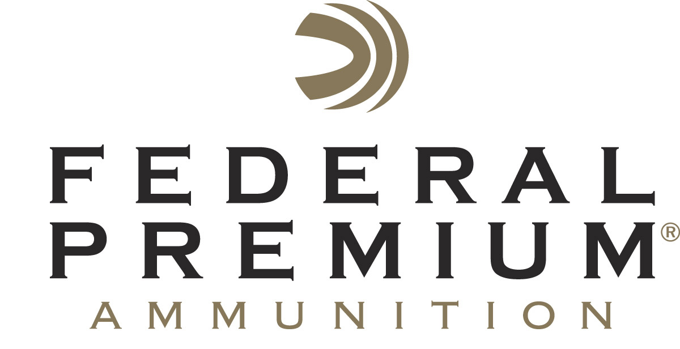
Contact: JJ Reich
Communications Manager
Firearms and Ammunition
(763) 323-3862
FOR IMMEDIATE RELEASE E-mail: pressroom@vistaoutdoor.com

Ballistic’s Best Magazine Bestows Federal Premium 224 Valkyrie with Best New Cartridge Award

ANOKA, Minnesota – May 23, 2018 – Athlon Outdoors' Ballistic magazine editors recently recognized Federal Premium’s 224 Valkyrie with an Editors' Choice award for Best New Cartridge in its inaugural issue of Ballistic's Best special interest publication. The new cartridge provides extremely flat trajectories, match accuracy and supersonic velocities beyond 1,300 yards. It also offers significantly less wind drift and drop than other loads in its class, as well as less than half the recoil of cartridges with comparable ballistics.

"It's not every day that ammo manufacturers come up with fodder that gets hardcore gun writers excited. Federal's new 224 Valkyrie has done so in spades. For that, we tip our caps," said Nino Bosaz, Athlon Outdoors' Editorial Director.

The Ballistic’s Best Awards were created to be the most prestigious honor in the firearms world, recognizing the top handguns, rifles, shotguns and more in a given year. Products recognized in Ballistic’s Best must meet the demanding criteria and testing protocols of Ballistic’s content creators and leading firearms experts.

“The list of awards for the world’s best MSR 15 cartridge is growing. We’re proud and excited about our new cartridge, and we deeply appreciate the honor Athlon Outdoors has unveiled to us,” said Federal Premium Ammunition Centerfire Rifle Product Director Mike Holm. “This new cartridge transforms the MSR 15 platform. Loaded in a full array of high-performance projectiles, 224 Valkyrie is the new choice for both long-range target shooters and hunters.”
Federal Premium’s new 224 Valkyrie cartridge is available in four of its proven product lines, offering serious options for competitors, long-range target shooters and hunters pursuing varmints up to deer-sized game. These options include 90-grain Gold Medal Sierra MatchKing, 60-grain Nosler Ballistic Tip Varmint, 90-grain Fusion MSR and 75-grain American Eagle TMJ.

Federal Premium is a brand of Vista Outdoor Inc., an outdoor sports and recreation company. For more information on Federal Premium, go to www.federalpremium.com.

About Vista Outdoor Inc.
Vista Outdoor is a leading global designer, manufacturer and marketer of consumer products in the growing outdoor sports and recreation markets. The company operates in two segments, Shooting Sports and Outdoor Products, and has a portfolio of well-recognized brands that provides consumers with a wide range of performance-driven, high-quality and innovative products for individual outdoor recreational pursuits. Vista Outdoor products are sold at leading retailers and distributors across North America and worldwide. Vista Outdoor is headquartered in Utah and has manufacturing operations and facilities in 13 U.S. States, Canada, Mexico and Puerto Rico along with international customer service, sales and sourcing operations in Asia, Australia, Canada and Europe. For news and information, visit www.vistaoutdoor.com or follow us on Twitter @VistaOutdoorInc and Facebook at www.facebook.com/vistaoutdoor.

###

