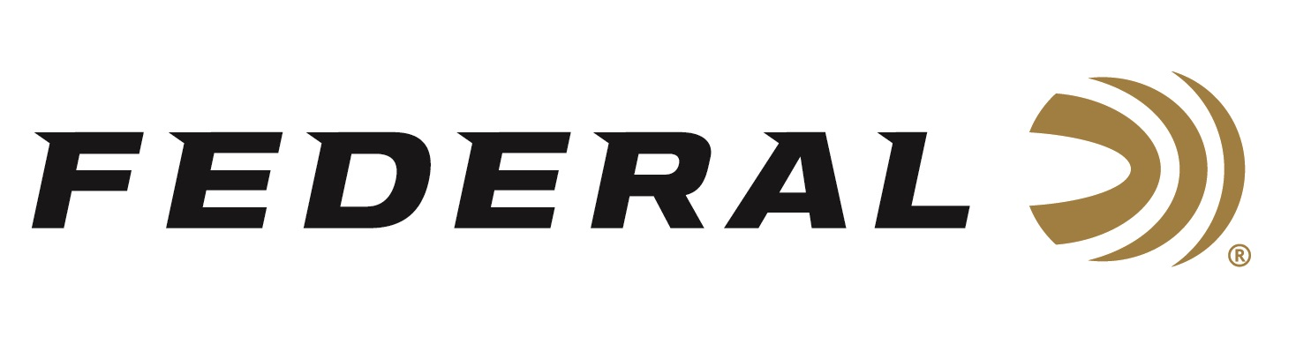

FOR IMMEDIATE RELEASE

Federal’s Bucks, Bulls & Blades Promotion Going Strong

ANOKA, Minnesota – August 29, 2019 – Federal’s Bucks, Bulls & Blades promotion program, in conjunction with Knives of Alaska, is currently underway. Through the program, customers who buy qualifying Federal Premium medium/big ammunition can get up to a $20 rebate, or a free Federal branded Knives of Alaska Cub Bear Suregrip caping knife, or the rebate and a knife.

Qualifying Federal products are limited to Edge TLR, Nosler AccuBond, Trophy Bonded Bear Claw, Trophy Bonded Tip, Trophy Copper, Sierra GameKing, Nosler Ballistic Tip, Nosler Partition, Cape-Shok, Barnes Triple-Shock X, Berger Hybrid Hunter, TruBall rifled slugs, Trophy Copper sabot slugs and Vital-Shok Buckshot.

Rebate options include:
- Spend $30 on qualifying product and get $10 back.
- Spend $90 on qualifying product and get one (1) knife. Retail value $64.99.
- Spend $120 on qualifying product and get $10 and one (1) knife.

Maximum $20 rebate and/or two (2) knives per person or household and Minimum purchase $30 are required. Product must be purchased between August 1, 2019 and December 31, 2019. Exclusions apply. See official terms and conditions for details.

Knives of Alaska’s Cub Bear Caping Knife has an overall length is 6-1/2 inches with a cutting edge of 2-3/4 inches. This blade is ideal for fine caping. Double finger choils provide excellent grip for safety and control. The extremely fine point razor-edged blade is perfect for close detail work. Knife features Suregrip handles that provide a slightly elastic soft sticky feel. A leather sheath is included. Learn more about Knives of Alaska, visit www.knivesofalaska.com.

For complete details on the Bucks, Bulls & Blades (Promotion No. P3851R), visit http://www.federalpremium.com/news/promotions_rebates.aspx.

For more information on Federal ammunition, visit www.federalpremium.com.

Press Release Contact: JJ Reich
Senior Communications Manager - Ammunition
E-mail: VistaPressroom@VistaOutdoor.com

About Federal Ammunition
Federal, headquartered in Anoka, MN, is a brand of Vista Outdoor Inc., an outdoor sports and recreation company. From humble beginnings nestled among the lakes and woods of Minnesota, Federal Ammunition has evolved into one of the world's largest producers of sporting ammunition. Beginning in 1922, founding president, Charles L. Horn, paved the way for our success. Today, Federal carries on Horn's vision for quality products and service with the next generation of outdoorsmen and women. We maintain our position as experts in the science of ammunition production. Every day we manufacture products to enhance our customers' shooting experience while partnering with the conservation organizations that protect and support our outdoor heritage. We offer thousands of options in our Federal Premium and Federal lines—it’s what makes us the most complete ammunition company in the business and provides our customers with a choice no matter their pursuit.

###

