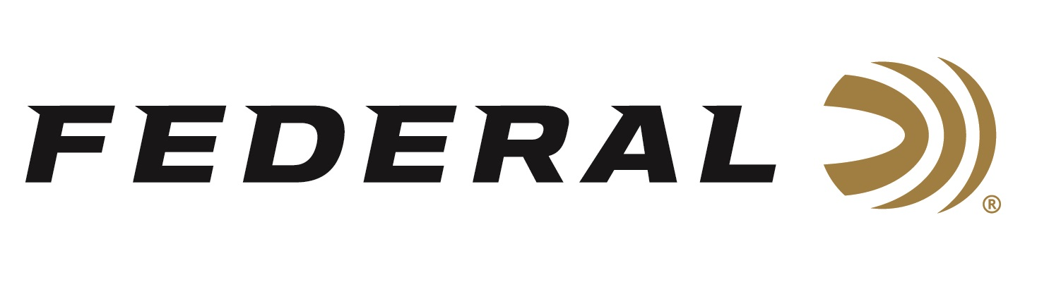
Contact: JJ Reich
Sr. Communications Manager
Firearms and Ammunition
(763) 323-3862
FOR IMMEDIATE RELEASE E-mail: pressroom@vistaoutdoor.com

Federal Ammunition Unveils New Enhanced Mobile Ballistics App

ANOKA, Minnesota – July 9, 2018 – Federal Ammunition’s new enhanced mobile app is a powerful tool to help hunters and shooters streamline and maximize all facets of the shooting experience.

“Technology drives everything at Federal Ammunition,” said Federal Senior Digital Marketing Manager Angie Sullivan. “This all-new app brings a range of advanced tools to one convenient place and allows you to access them even while offline.”

Compatible with Apple and Android smartphones and tablets, the new ballistics app features updated ballistic calculator data and the ability to save ballistics, plus updated ammo recommendations and a fresh, new, user-friendly design.

“With the new Federal Ammunition app, hunters and shooters can quickly and easily determine the trajectory for any rifle or handgun load, and save the data for future reference,” Sullivan continued. “Plus, the app allows you to identify which ammunition to use in a variety of shooting situations, locate your closest Federal dealer and find a nearby shooting range where you can enjoy all the benefits of Federal’s industry leading products.”

The ballistics app also offers detailed information on the components and technology that set Federal Premium products apart from other ammunition.

Consumers can get the app through the iTunes Store or Google Play.

For more information about Federal Ammunition and the new ballistics app, go to www.federalpremium.com.

About Federal Ammunition
Federal, headquartered in Anoka, MN, is a brand of Vista Outdoor Inc., an outdoor sports and recreation company. From humble beginnings nestled among the lakes and woods of Minnesota, Federal Ammunition has evolved into one of the world's largest producers of sporting ammunition. Beginning in 1922, founding president, Charles L. Horn, paved the way for our success. Today, Federal carries on Horn's vision for quality products and service with the next generation of outdoorsmen and women. We maintain our position as experts in the science of ammunition production. Every day we manufacture products to enhance our customers' shooting experience while partnering with the conservation organizations that protect and support our outdoor heritage. We offer thousands of options in our Federal Premium and Federal lines-it's what makes us the most complete ammunition company in the business and provides our customers with a choice no matter their pursuit. For more information on Federal, visit www.federalpremium.com.

###

