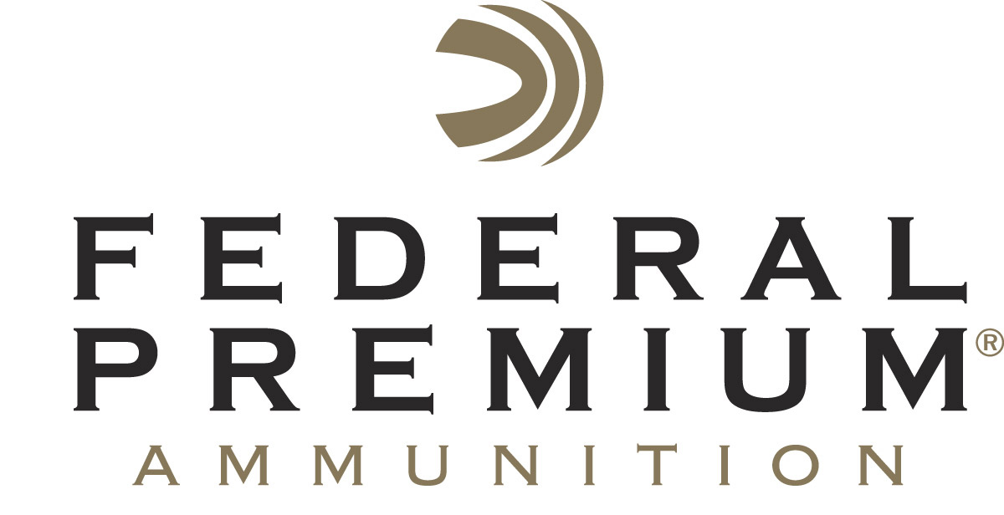
Contact: JJ Reich
Communications Manager
Firearms and Ammunition
(763) 323-3862
FOR IMMEDIATE RELEASE E-mail: pressroom@vistaoutdoor.com

FBI Awards Contract for up to $19 Million of Specifically Designed Federal Premium Training Ammunition

ANOKA, Minnesota – April 26, 2018 – The Federal Bureau of Investigation (FBI) has awarded Vista Outdoor a contract to supply FBI and other Federal Government Agencies with a high-performance Federal Premium 9mm handgun training round specifically designed to support their mission.

The IDIQ (indefinite delivery/indefinite quantity) contract, which has four option years, is for up to $19 million in 9mm handgun training rounds. This ammunition is built distinctively to FBI’s specifications using Federal Premium’s precision manufacturing and testing methods, innovative technology, and industry-leading components.

“We are extremely proud of this important contract, which continues Federal Premium’s long-running tradition of supplying law enforcement, military personnel and civilians worldwide with the most reliable ammunition possible,” said Federal Premium President Jason Vanderbrink. “This high-value, optimized training round utilizes a new match-grade bullet designed specifically for the FBI to maximize accuracy, along with Federal Premium’s Catalyst lead-free primer formulation to provide reliable, consistent ignition.”

Since 1922, Federal Premium Ammunition has been a staple for shooters wanting high-quality shotshell, centerfire and rimfire ammunition. The company’s relentless pursuit of excellence and innovation has resulted in numerous technological breakthroughs, such as the patented Catalyst primer used in the new FBI training round.

The extremely clean-burning Catalyst primer creates more uniform and complete propellant combustion, yielding minimal velocity variation and consistent bullet launch for improved accuracy. It is also non-hydrophilic, so it does not attract water molecules like DDNP-based mixes found in most lead-free primers, resulting in better reliability. The Federal Premium proprietary Catalyst primer provides the cleanest, most consistent ignition possible.

Civilians and other Law Enforcement agencies looking for similar high-performance primers in their range ammunition can find it in Federal’s full lineup of lead-free American Eagle and Syntech ammunition. The polymer-encapsulated Syntech bullet prevents metal-on-metal contact between the bullet and bore, which can shorten barrel life and rob accuracy, while also eliminating copper and lead fouling. Combined with specialized clean-burning powders, your gun will stay cleaner longer, so you can shoot more - and shoot better.

For more information on Federal Premium ammunition and components, go to www.federalpremium.com.

About Vista Outdoor
Vista Outdoor is a leading global designer, manufacturer and marketer of consumer products in the growing outdoor sports and recreation markets. The company operates in two segments, Shooting Sports and Outdoor Products, and has a portfolio of well-recognized brands that provides consumers with a wide range of performance-driven, high-quality and innovative products for individual outdoor recreational pursuits. Vista Outdoor products are sold at leading retailers and distributors across North America and worldwide. Vista Outdoor is headquartered in Utah and has manufacturing operations and facilities in 13 U.S. States, Canada, Mexico and Puerto Rico along with international customer service, sales and sourcing operations in Asia, Australia, Canada, and Europe. For news and information, visit www.vistaoutdoor.com or follow us on Twitter @VistaOutdoorInc and Facebook at www.facebook.com/vistaoutdoor.

###

