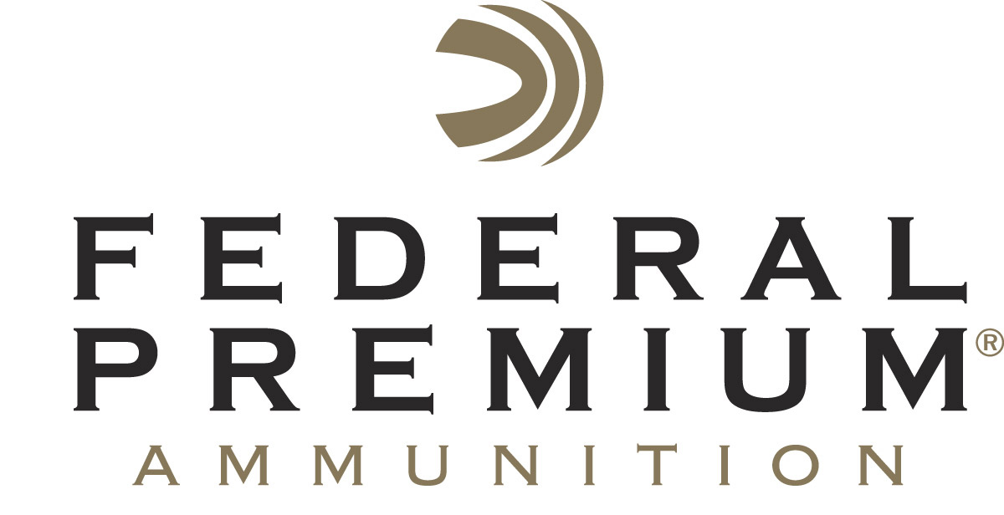
Contact: JJ Reich
Communications Manager
Firearms and Ammunition
(763) 323-3862
FOR IMMEDIATE RELEASE E-mail: pressroom@vistaoutdoor.com

Federal Premium Continues Long-Term Relationship with Lake City Army Ammunition Plant

ANOKA, Minnesota – January 23, 2018 – Federal Premium is proud to continue its long-term working relationship with the Lake City Army Ammunition Plant in Independence, Missouri. For 10 years, Federal has been working hand-in-hand with the facility, fueling the shooting sports and American freedom with the industry’s most consistent, reliable and affordable small arms rounds.

“For the past decade, we have fostered a relationship with the Lake City Army Ammunition plant to build some of the industry’s leading ammunition,” said Federal Premium Centerfire Product Director Mike Holm. “We're proud to continue this today and deliver shooters a full spectrum of military-grade, American-made loads.”

Examples of quality Federal ammunition produced at the Lake City Army Ammunition plant include Federal’s XM855 5.56x45mm 62-grain green tip full metal jacket and XM33C 50 BMG full metal jacket. Both are loaded to true NATO specifications and meet strict quality assurance standards. Each round is brass-cased, boxer-primed, non-corrosive and reloadable. They are both economical and precision manufactured in the U.S.A.

With the capacity to produce millions of rounds per day, all with Lake City’s famed mil-spec brass and bullets, the facility ensures Federal continues to provide its customers with the ammunition they need and the quality they expect.

“Like Federal, the Lake City facility’s reputation is built on hard work, attention to detail and the dedication to produce the very best,” said Holm. “Its 76-year track record of crafting high-quality ammunition speaks for itself, and Lake City components have earned the trust of the most discriminating shooters. We look forward to working together for many more years to come, delivering quality ammunition to customers worldwide.”

Federal Premium is a brand of Vista Outdoor Inc., an outdoor sports and recreation company. For more information on Federal Premium, go to www.federalpremium.com.

About Vista Outdoor
Vista Outdoor is a leading global designer, manufacturer and marketer of consumer products in the growing outdoor sports and recreation markets. The company operates in two segments, Shooting Sports and Outdoor Products, and has a portfolio of well-recognized brands that provides consumers with a wide range of performance-driven, high-quality and innovative products for individual outdoor recreational pursuits. Vista Outdoor products are sold at leading retailers and distributors across North America and worldwide. Vista Outdoor is headquartered in Utah and has manufacturing operations and facilities in 13 U.S. States, Canada, Mexico and Puerto Rico along with international customer service, sales and sourcing operations in Asia, Australia, Canada, and Europe. For news and information, visit www.vistaoutdoor.com or follow us on Twitter @VistaOutdoorInc and Facebook at www.facebook.com/vistaoutdoor.

