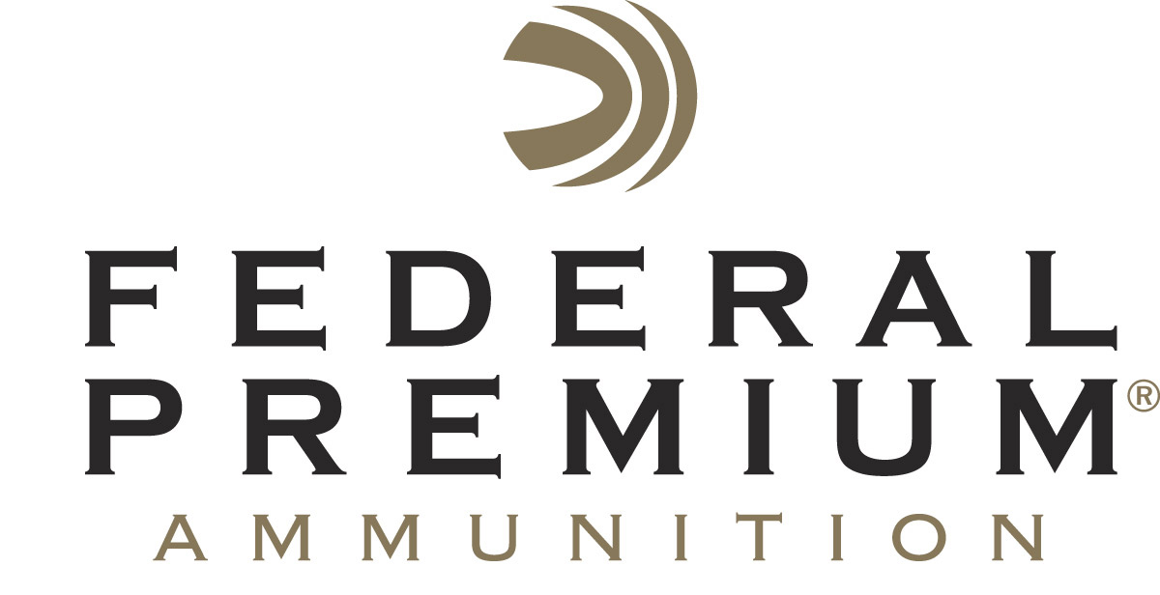
Contact: JJ Reich
Communications Manager
Firearms and Ammunition
(763) 323-3862
FOR IMMEDIATE RELEASE E-mail: pressroom@vistaoutdoor.com

Federal Premium Becomes Official
Shotshell Ammunition Sponsor of USA Shooting

ANOKA, Minnesota – April 2, 2018 – Federal Premium Ammunition is pleased to announce it is now the official shotshell ammunition sponsor and supplier of USA Shooting. The sponsorship strengthens the non-profit organization’s efforts to promote the shooting sports and prepare American athletes to bring home gold from Tokyo in summer of 2020.

“We are extremely proud to support USA Shooting’s mission and supply U.S. athletes with the world-class firepower of Federal Premium Gold Medal shotshells,” said Federal Premium President Jason Vanderbrink. “High-performance Gold Medal rounds have a rich tradition of breaking records and achieving victory in competitions ranging from local matches to national championships and the world stage.”

USA Shooting was chartered by the United States Olympic Committee as the National Governing Body for the sport of shooting in April 1995. The group's mission is to prepare American athletes to win Olympic medals, promote shooting sports activities throughout the U.S., govern the conduct of international shooting in the country, and aid in developing the next generation of responsible gun owners and sports participants. For details, visit: usashooting.org.

"I am proud to welcome Federal Premium to our team,” said USA Shooting CEO Keith Enlow. “The gold-medal aspirations of our athletes and organization requires us to engage partners that embody the same Olympic mindset and drive, with a willingness to support America’s shooting team and showcase our athletes and sport in new, exciting ways. We have athletes in need and it is this type of sponsorship support that truly allows them to train and compete around the world in pursuit of their Olympic and Paralympic dreams.”

Federal Premium is set to join forces with the world’s top shotgun program as America’s shotgun athletes earned 13 World Championship medals in 2017 while winning 27 Olympic medals overall.
As part of the new partnership, Federal Premium will also collaborate on marketing efforts and create specially marked boxes of Gold Medal shotshell, pistol and rifle ammunition to build greater awareness of USA Shooting.

Serious shooters have long relied on Federal Premium Gold Medal shotshells to dominate the competition in trap, skeet and sporting clay events worldwide. Year after year, Gold Medal rounds have broken world records and won top honors at prestigious shoots like the ATA Grand American, earning the respect of all levels of competitive shooters. The enhanced design of new Gold Medal Grand shotshells, introduced in 2017, builds on that tradition with less felt recoil, more reliable ignition, improved patterns, harder shot and maximum downrange power.

Federal Premium is a brand of Vista Outdoor Inc., an outdoor sports and recreation company. For more information on Federal Premium, go to www.federalpremium.com.

About Vista Outdoor
Vista Outdoor is a leading global designer, manufacturer and marketer of consumer products in the growing outdoor sports and recreation markets. The company operates in two segments, Shooting Sports and Outdoor Products, and has a portfolio of well-recognized brands that provides consumers with a wide range of performance-driven, high-quality and innovative products for individual outdoor recreational pursuits. Vista Outdoor products are sold at leading retailers and distributors across North America and worldwide. Vista Outdoor is headquartered in Utah and has manufacturing operations and facilities in 13 U.S. States, Canada, Mexico and Puerto Rico along with international customer service, sales and sourcing operations in Asia, Australia, Canada, and Europe. For news and information, visit www.vistaoutdoor.com or follow us on Twitter @VistaOutdoorInc and Facebook at www.facebook.com/vistaoutdoor.

###

