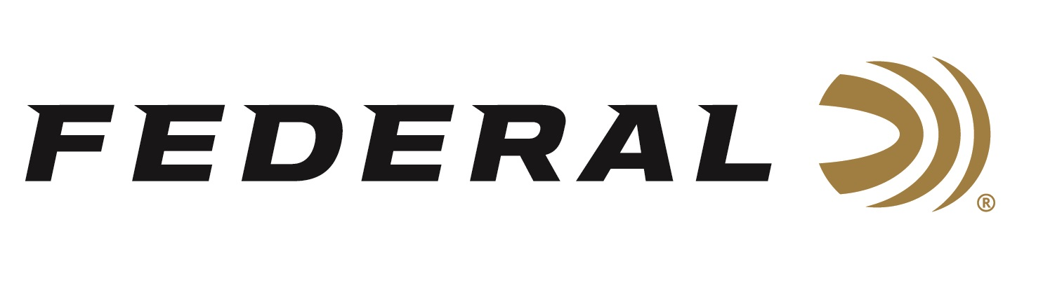
Contact: JJ Reich
Sr. Communications Manager
Firearms and Ammunition
(763) 323-3862
FOR IMMEDIATE RELEASE E-mail: pressroom@vistaoutdoor.com

Federal Ammunition Launches Enhanced New Website

ANOKA, Minnesota – July 6, 2018 – Federal Ammunition’s new website makes it faster and easier to choose the right loads, learn about industry-leading products and the technology behind them and find the best deals on ammo. Our redesigned site with enriched content, action photos and engaging videos will allow you to fully immerse yourself in the world of hunting and shooting sports.

For starters, visitors can easily access detailed product information and load selection advice on the world’s top ammunition for big game, varmints, waterfowl, upland game, wild turkeys, personal defense, target shooting and competition. For customers’ convenience, special promotions are now integrated into product pages, and the “Where to Buy” feature lists locations of the nearest Federal retailers.

“But that’s only the beginning of what the new, user-friendly website offers hunters and shooters,” said Federal Senior Director of Marketing Jason Nash. “The new web site signifies our longstanding commitment to quality, as well as educating and informing our consumers of our broad product lines. Leading the charge is our bold new Federal logo which signals a stronger, more focused and authentic branding approach.”

Users will experience quick access to comprehensive details on each of Federal’s outstanding offerings. Find the right product using enhanced filters to multi-select from caliber/gauge, bullet style, use, product family, bullet weight, shell type; Enhanced search functionality helping you easily find products and articles; Updated “Ammo Recommendation” feature includes new products such as 224 Valkyrie; and more.

“The site allows visitors to experience the world of shooting and learn from the pros in 50 ‘Premium Moments’ stories featuring interviews with country music stars, YouTube influencers and champion shooters,” Nash continued. “You can also subscribe to the industry’s best e-newsletter and get monthly updates on new products and news; view highlights from social media posts from Federal’s vast network of fans; learn about new products like the award-winning, industry-changing 224 Valkyrie and Heavyweight TSS; and perfectly dial in your shooting with data powered by the ‘Premium Ballistics Engine.’”
Additional Features Include:
- Dynamic Federal Ballistics Calculator helps users quickly determine the trajectory for any rifle or handgun load and save data for an unlimited number of loads, including previously saved loads from the former site.
- Extended “Reloading” section which includes component products and rifle and handgun reloading data that lets users choose their cartridge and filter by attributes such as bullet weight and powder type to find the exact recipe for producing the desired performance.
- Lifestyle videos including stories on brand ambassadors, hunting, shooting sports, advocacy, conservation, education and mentoring.
- Upgraded user engagement including access to Frequently Asked Questions section, ability to read reviews, rate Federal products and share opinions, experiences, images and videos.
- Highlights from Federal’s social media channels, plus opportunities to join the conversation and be featured on the Federal website.

Federal’s new site is also built for optimum viewing and navigation on all devices, ensuring a fast, seamless experience for all users.

To view the new site, go to www.federalpremium.com.

About Federal Ammunition
Federal, headquartered in Anoka, MN, is a brand of Vista Outdoor Inc., an outdoor sports and recreation company. From humble beginnings nestled among the lakes and woods of Minnesota, Federal Ammunition has evolved into one of the world's largest producers of sporting ammunition. Beginning in 1922, founding president, Charles L. Horn, paved the way for our success. Today, Federal carries on Horn's vision for quality products and service with the next generation of outdoorsmen and women. We maintain our position as experts in the science of ammunition production. Every day we manufacture products to enhance our customers' shooting experience while partnering with the conservation organizations that protect and support our outdoor heritage. We offer thousands of options in our Federal Premium and Federal lines-it's what makes us the most complete ammunition company in the business and provides our customers with a choice no matter their pursuit. For more information on Federal, visit www.federalpremium.com.

###

