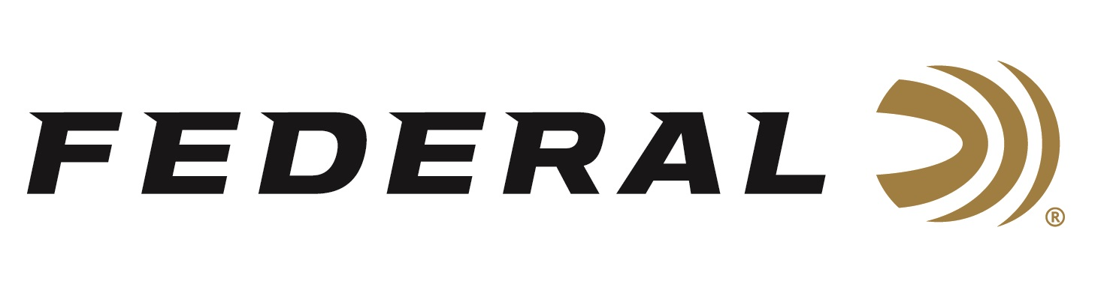
Contact: JJ Reich
Sr. Communications Manager
Firearms and Ammunition
(763) 323-3862
FOR IMMEDIATE RELEASE E-mail: pressroom@vistaoutdoor.com

Federal Continues Longtime Support of 4-H Shooting Sports

ANOKA, Minnesota – July 3, 2018 – Federal Ammunition is pleased to continue its sponsorship and support of one of the largest and longest running gateways to a variety of shooting disciplines—the National 4-H Shooting Sports Program.

Federal Ammunition was a top-level sponsor of the 2018 4-H Shooting Sports National Championships, held June 24-29 in Grand Island, Nebraska. The company also supports 4-H leadership training efforts and 4-H Shooting Sports programs down to the local level. In addition, Federal Ammunition has supported 4-H conservation programs since 1934 and the organization’s shooting sports program since 1976.

The National 4-H Shooting Sports Program offers boys and girls ages 8 to 18 instruction and competitive opportunities in disciplines including archery, muzzleloading, pistol, rifle and shotgun. Currently more than 450,000 youths and 20,000 state- and national-certified volunteer instructors are active in 4-H shooting sports programs directed through the Cooperative Extension Service of the Land Grant Universities in 47 states across the United States.

“National 4-H Shooting Sports programs are honored to have the continuing support of Federal Ammunition,” said National 4-H Shooting Sports Coordinator Conrad Arnold. “Federal was instrumental in the establishment of 4-H shooting sports programs in its developmental years beginning in 1976. Over the years, the company’s financial support, encouragement and advice have helped make 4-H shooting sports the largest youth shooting program in the U.S.”

The focus of all 4-H programs is the development of youth as individuals and as responsible and productive citizens. The National 4-H Shooting Sports Program stands out as an example. Youths learn marksmanship, the safe and responsible use of firearms and archery, the principles and ethics of hunting, and more. The activities of the program and the support of dedicated adult leaders provide young people with opportunities to develop life skills, self-worth and conservation ethics.

“We could not be more excited about our continued relationship with such a safely operated educational program passing on our outdoor heritage,” said Jon Zinnel, Federal Ammunition Education and Conservation Outreach Specialist. “Federal, 4-H Shooting Sports’ longest running supporter, is proud to continue its relationship and help provide this great opportunity for thousands more youth across the country.”

For information about 4-H shooting sports programs, visit www.4-hshootingsports.org. To learn more about sponsorship opportunities, contact Conrad Arnold, National 4-H Shooting Sports Program Coordinator, at: carnold@umd.edu or (410) 330-5967.

For more information on Federal, visit www.federalpremium.com.

About Federal Ammunition
Federal Ammunition, headquartered in Anoka, MN, is a brand of Vista Outdoor Inc., an outdoor sports and recreation company. From humble beginnings nestled among the lakes and woods of Minnesota, Federal Ammunition has evolved into one of the world's largest producers of sporting ammunition. Beginning in 1922, founding president, Charles L. Horn, paved the way for our success. Today, Federal carries on Horn's vision for quality products and service with the next generation of outdoorsmen and women. We maintain our position as experts in the science of ammunition production. Every day we manufacture products to enhance our customers' shooting experience while partnering with the conservation organizations that protect and support our outdoor heritage. We offer thousands of options in our Federal Premium and Federal lines—It's what makes us the most complete ammunition company in the business and provides our customers with a choice no matter their pursuit. For more information on Federal, visit www.federalpremium.com.

###

