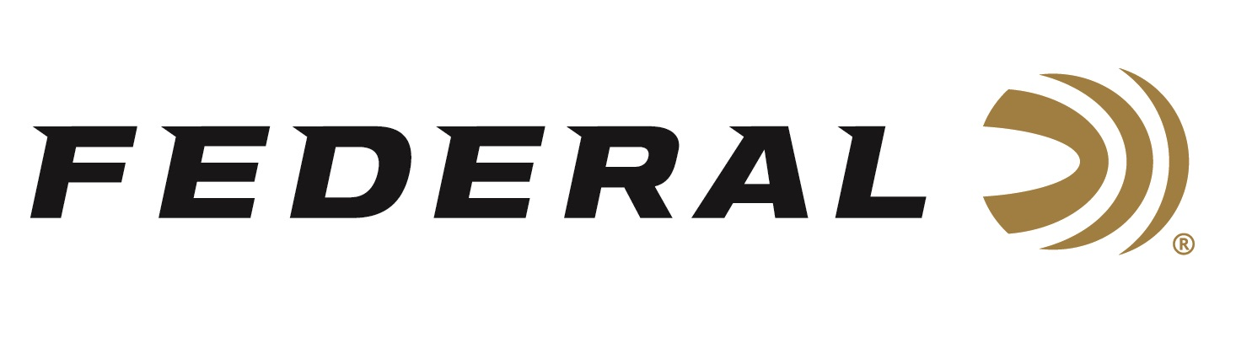

FOR IMMEDIATE RELEASE

Federal’s HEAVYWEIGHT TSS Turkey Loads Named Best of the Best by Field & Stream Magazine

ANOKA, Minnesota – December 3, 2018 – Federal Ammunition is proud to announce its Premium HEAVYWEIGHT TSS turkey loads have been honored by Field & Stream as a 2018 Best of the Best product. This honor is featured in the December/January issue of the magazine, now available on newsstands.

“We know the editors of Field & Stream rigorously test hundreds of new products each year, yet only a handful are selected as the Best of the Best,” said Federal Shotshell Director Rick Stoeckel. “This honor proves the effectiveness of the ammunition itself and is a testament to the hard work our dedicated engineers and factory workers have poured into it. We are extremely proud of and grateful for this announcement.”

Federal Premium HEAVYWEIGHT TSS shotshells represent a big upgrade from anything previously available, letting hunters kill gobblers at longer distances than ever thought possible. Payloads of No. 7 or 9 Tungsten Super Shot provide extremely high pellet counts—in many cases, more than double those lead loads of the same weight. The shot’s 18 gram per cubic centimeter density provides optimum energy and the highest velocities at long ranges. The full-length, rear-braking FLITECONTROL FLEX wad protects the barrel as TSS travels down it. The wad also provides the tightest, most consistent patterns possible through ported and standard choke tubes, maximizing the number of pellets in a 10-inch circle at 40 yards. The shells come in five-count packs, and a portion of all proceeds is donated to the National Wild Turkey Federation.

The following is part of Field & Stream’s article:

“So, how does TSS work on turkeys? I watched the 12-gauge loads tumble half a dozen birds, including a couple of my own, at ranges from 10 to 40 yards,” Field & Stream Hunting Editor Will Brantley. “I can say with confidence that if you have even the slightest doubt about No. 9 TSS pellets’ lethality on a tom, don’t.”

For more information on Federal Ammunition, visit www.federalpremium.com.

Press Release Contact: JJ Reich
Senior Communications Manager - Firearms and Ammunition
E-mail: VistaPressroom@VistaOutdoor.com

About Federal Ammunition
Federal, headquartered in Anoka, MN, is a brand of Vista Outdoor Inc., an outdoor sports and recreation company. From humble beginnings nestled among the lakes and woods of Minnesota, Federal Ammunition has evolved into one of the world's largest producers of sporting ammunition. Beginning in 1922, founding president, Charles L. Horn, paved the way for our success. Today, Federal carries on Horn's vision for quality products and service with the next generation of outdoorsmen and women. We maintain our position as experts in the science of ammunition production. Every day we manufacture products to enhance our customers' shooting experience while partnering with the conservation organizations that protect and support our outdoor heritage. We offer thousands of options in our Federal Premium and Federal® lines-it's what makes us the most complete ammunition company in the business and provides our customers with a choice no matter their pursuit.

