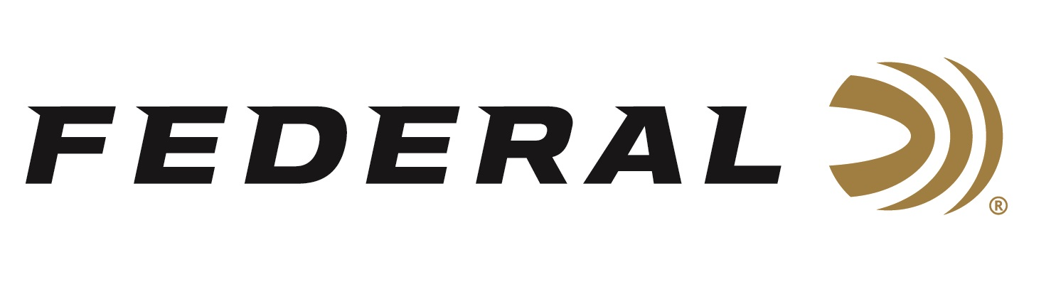
Contact: JJ Reich
Communications Manager
Firearms and Ammunition
(763) 323-3862
FOR IMMEDIATE RELEASE E-mail: pressroom@vistaoutdoor.com

Federal Premium Shooter Vincent Hancock Captures Third Straight Skeet World Cup Gold

ANOKA, Minnesota – June 20, 2018 – Federal Premium Ammunition sponsored shooter and brand ambassador Vincent Hancock extended his 2018 winning streak by capturing his third consecutive Men’s Skeet World Cup gold medal of the season.

The two-time Olympic champion took top honors at the International Shooting Sport Federation (ISSF) World Cup in Siggiwei, Malta. His previous 2018 World Cup golds came in Guadalajara, Mexico, and Changwon, Korea.

It was the 10th World Cup gold medal in the 29-year-old American shooter’s illustrious career and, by his own admission, one of the hardest fought victories.

“This was definitely one of hardest competitions to shoot in,” Hancock said as the dust settled after a rollercoaster finish. “The wind was definitely a factor in the last few days. Today it kind of settled down a little bit, the targets were more consistent and we saw a lot of high scores. Unfortunately in the final we all missed quite a few targets, there was a little bit of a glare because of the sun getting so low behind the high house.”

After missing targets number 39 and 40 at station 5, Hancock slipped into 2nd place before nailing a perfect streak of 20 hits to seal his win with 56 hits out of 60 clays.

Hancock leads Federal Premium Ammunition’s support for USA Shooting, a non-profit organization that promotes the shooting sports and prepares American athletes to bring home Olympic gold. For details, visit: www.usashooting.org.

A decorated military veteran, Hancock served as a sergeant in the U.S. Army Marksmanship Unit and was awarded the National Defense Service Medal, Global War on Terrorism Service Medal, Army Service Ribbon and Distinguished International Shooter Badge.

“We are very proud of Team Federal’s Vincent Hancock and his accomplishments in competition, along with his dedication to serving our country and promoting the shooting sports,” said Federal Premium Senior Director of Marketing Jason Nash. “We look forward to being part of his many successes and his march to Tokyo in 2020.”

Serious shooters have long relied on Federal Premium Gold Medal shotshells to dominate the competition in trap, skeet and sporting clay events worldwide. Year after year, Gold Medal rounds have broken world records and won top honors at prestigious shoots like the World Cup and ATA Grand American, earning the respect of all levels of competitive shooters. The enhanced design of new Gold Medal Grand shotshells, introduced in 2017, builds on that tradition with less felt recoil, more reliable ignition, improved patterns, harder shot and maximum downrange power.

For more information on Federal, visit www.federalpremium.com.

About Federal Premium
Federal Premium, headquartered in Anoka, MN, is a brand of Vista Outdoor Inc., an outdoor sports and recreation company. From humble beginnings nestled among the lakes and woods of Minnesota, Federal Premium Ammunition has evolved into one of the world's largest producers of sporting ammunition. Beginning in 1922, founding president, Charles L. Horn, paved the way for our success. Today, Federal carries on Horn's vision for quality products and service with the next generation of outdoorsmen and women. We maintain our position as experts in the science of ammunition production. Every day we manufacture products to enhance our customers' shooting experience while partnering with the conservation organizations that protect and support our outdoor heritage. We offer thousands of options in our Federal Premium and Federal® lines-it's what makes us the most complete ammunition company in the business and provides our customers with a choice no matter their pursuit.

###

