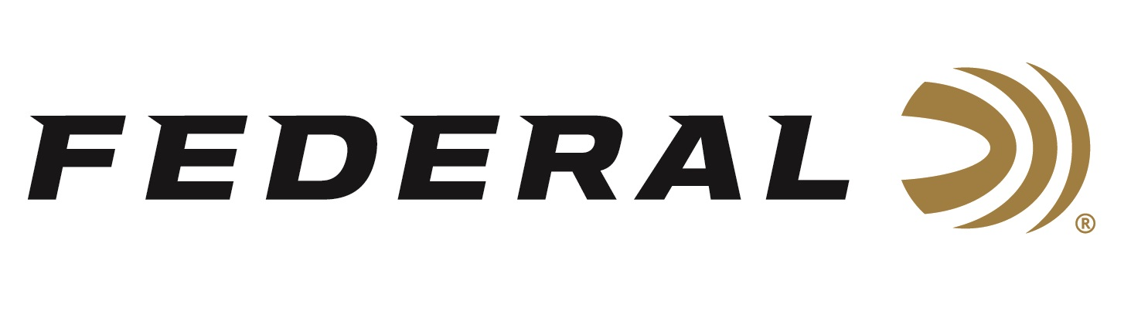

FOR IMMEDIATE RELEASE

Federal Premium Shooters Vincent Hancock and Caitlin Connor
Crowned World Champions

ANOKA, Minnesota – September 18, 2018 – Federal Premium Ammunition sponsored shooters and brand ambassadors Vincent Hancock and Caitlin Connor each won gold medals and were crowned world champions at the International Shooting Sport Federation (ISSF) World Championship in Changwon, South Korea, held August 31 to September 15, 2018.

The two-time Olympic gold medalist Hancock picked up his fourth World Championship title in Men’s Skeet to close the World Championships. Hancock marched through the rainy qualification rounds without a miss over 125 targets and only missed once in the final to secure his place in the record books. Hancock becomes the first person ever to win four World titles in Men’s Skeet and is also now one of three men in the Shotgun discipline to earn four world titles in his career.

Along with the gold, Hancock also secured an Olympic Men’s Skeet quota for the United States. A quota is essentially a country’s ticket to participate in a specific event in the 2020 Olympic Games in Tokyo, Japan. In Shooting competition at the Olympic Games, a country can earn up to two quotas in each event – but that doesn’t guarantee a specific athlete to compete in the Games, just that his/her country has a spot to do so.

In her final, Caitlin Connor didn’t miss until the 35th target and finished with a score of 57. Olympic shooting legend Kim Rhode won silver and Amber English took the bronze, marking the first U.S. sweep ever in women’s skeet.

“The final was very exciting,” said Connor. “I was a little nervous at first, but then I got into the groove and had fun shooting with my teammates. It feels really good to have had three U.S. flags up there. I was glad it was us three. It was a great day for USA.”

This win was Connor’s first international gold medal. She won silver in 2015 and six other World Cup silver medals across her career. Coming into the competition, Rhode was ranked No. 1 in the world, Connor third and English fourth. In addition to the podium sweep, the United States claimed the maximum number of two Olympic Games quotas available in Women’s Skeet.

“We are very proud of Team Federal’s Caitlin Connor and Vincent Hancock for their wins at the World Championships,” said Federal Premium Senior Director of Marketing Jason Nash. “We look forward to being part of many more of their successes and this team’s march to Tokyo in 2020.”

In other competition news, Nic Moschetti added to Team USA’s outstanding shotgun performance in Changwon, capturing the silver medal in Men’s Junior Skeet while Austen Smith earned herself a bronze medal in Junior Women’s Skeet. Kayle Browning and Ashley Connor earned a bronze medal in the Women’s Trap Team event alongside Aeriel Skinner. In total, the U.S. Shotgun Team, sponsored by Federal Premium, earned 12 medals including three gold, four silver, and five bronze.

Serious shooters have long relied on Federal Premium Gold Medal shotshells to dominate the competition in trap, skeet and sporting clay events worldwide. Year after year, Gold Medal rounds have broken world records and won top honors at prestigious shoots like the World Cup and ATA Grand American, earning the respect of all levels of competitive shooters. The enhanced design of new Gold Medal Grand shotshells, introduced in 2017, builds on that tradition with less felt recoil, more reliable ignition, improved patterns, harder shot and maximum downrange power.

Federal Premium recently became the official shotshell ammunition sponsor and supplier of USA Shooting, a non-profit organization that promotes the shooting sports and prepares American athletes to bring home Olympic gold. For more information on Federal, visit www.federalpremium.com.

Press Release Contact: JJ Reich
Senior Communications Manager - Firearms and Ammunition
E-mail: VistaPressroom@VistaOutdoor.com

About Federal Ammunition
Federal, headquartered in Anoka, MN, is a brand of Vista Outdoor Inc., an outdoor sports and recreation company. From humble beginnings nestled among the lakes and woods of Minnesota, Federal Ammunition has evolved into one of the world's largest producers of sporting ammunition. Beginning in 1922, founding president, Charles L. Horn, paved the way for our success. Today, Federal carries on Horn's vision for quality products and service with the next generation of outdoorsmen and women. We maintain our position as experts in the science of ammunition production. Every day we manufacture products to enhance our customers' shooting experience while partnering with the conservation organizations that protect and support our outdoor heritage. We offer thousands of options in our Federal Premium and Federal® lines-it's what makes us the most complete ammunition company in the business and provides our customers with a choice no matter their pursuit.

