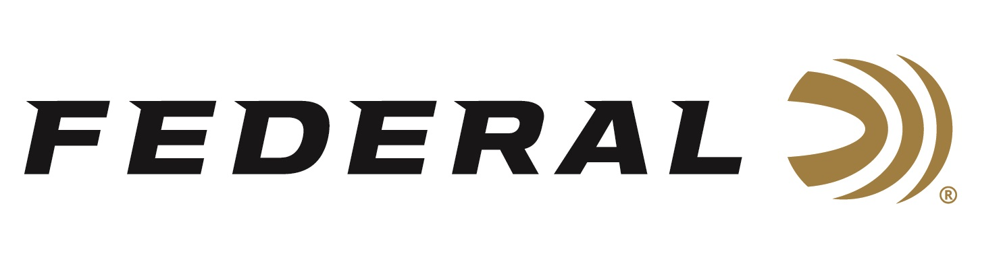
Contact: JJ Reich
Sr. Communications Manager
Firearms and Ammunition
(763) 323-3862
FOR IMMEDIATE RELEASE E-mail: pressroom@vistaoutdoor.com

Federal Awards the International Hunter Education Volunteer Instructor of the Year

ANOKA, Minnesota – July 2, 2018 – Federal Ammunition announced Marsha Womack as the recipient of the 2017 International Hunter Education Association-USA (IHEA-USA) Volunteer Instructor of the Year Award during the 2018 IHEA-USA Annual Conference.

Womack, of Modesto, California, is a tireless advocate of hunting, the shooting sports and firearms safety. In 2017 she conducted a total of 53 traditional and online classes that resulted in the certification of 1,227 students. Her efforts were similar in 2016, when she taught 52 classes that certified 1,145 students.

Womack is also an avid big-game hunter and member of the National Rifle Association, Rocky Mountain Elk Foundation and Tuolumne County Sportsmen, which she has assisted with conservation projects including placing salt blocks on winter deer ranges.

“Marsha’s commitment to hunter education and her passion for hunting, shooting and firearms safety are a shining example of the many dedicated volunteers nationwide who help ensure the future of our hunting heritage,” said Jon Zinnel from Federal ’s Education Outreach department. “Marsha proudly advertises her classes with a decal on the side of her vehicle. She encourages students throughout the teaching process and keeps in touch with many for years afterward.”

Federal Ammunition has sponsored the IHEA-USA for more than a decade. The respected award was presented to Womack during the 2018 IHEA-USA Annual Conference, held June 25-28 in Anchorage, Alaska.

For more on IHEA-USA and to learn how you can help support the future of hunting and hunter education, visit www.ihea-usa.org.

To view Federal’s new web site, go to www.federalpremium.com.

Photo: Presenter Jake Edson and recipient Marsha Womack

About Federal Ammunition
Federal Ammunition, headquartered in Anoka, MN, is a brand of Vista Outdoor Inc., an outdoor sports and recreation company. From humble beginnings nestled among the lakes and woods of Minnesota, Federal Ammunition has evolved into one of the world's largest producers of sporting ammunition. Beginning in 1922, founding president, Charles L. Horn, paved the way for our success. Today, Federal carries on Horn's vision for quality products and service with the next generation of outdoorsmen and women. We maintain our position as experts in the science of ammunition production. Every day we manufacture products to enhance our customers' shooting experience while partnering with the conservation organizations that protect and support our outdoor heritage. We offer thousands of options in our Federal and Federal® lines-it's what makes us the most complete ammunition company in the business and provides our customers with a choice no matter their pursuit. For more information on Federal, visit www.federalpremium.com.

###

