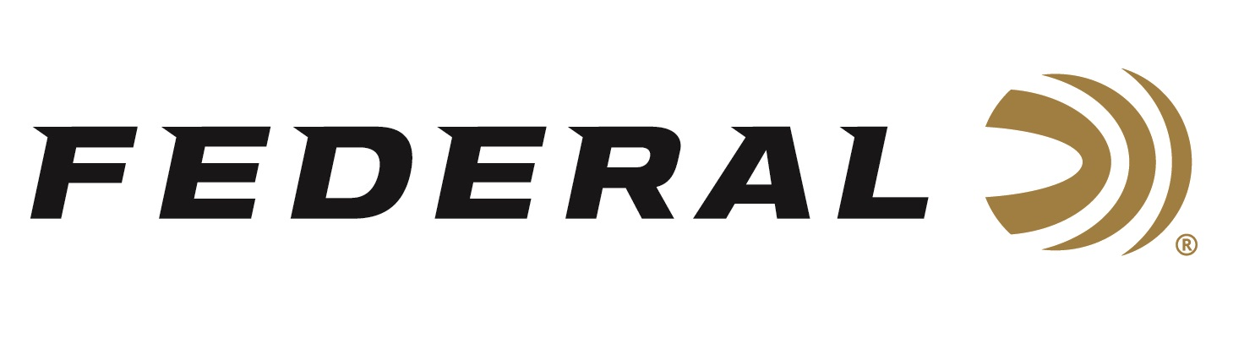

FOR IMMEDIATE RELEASE

Federal Ammunition Announces New Loads in 450 Bushmaster

ANOKA, Minnesota – December 3, 2018 – Federal is proud to announce new loads for hunting chambered in the popular 450 Bushmaster straight-wall cartridge. Shipments of Power-Shok ammunition are being delivered to dealers now. Fusion and Non-Typical will soon follow.

Legal in more “slug-only” areas and offering enhanced range, accuracy and power over other straight-walled rifle cartridges and sabots, the 450 Bushmaster is becoming a new favorite of deer, hog and bear hunters. Now the hot cartridge is available in three of the best loads for hunters—Federal Fusion (bonded), Power-Shok and Non-Typical. All get the most from the round thanks to consistent, accurate bullet designs that expand reliably.

Features & Benefits
- Superior range and accuracy over other straight-wall rifle cartridges and sabot slugs
- Legal for hunting in many areas where other centerfire rifle cartridges are prohibited
- Fusion bonded bullets offers best-in-class expansion
- Non-Typical is specifically built for deer hunters
- Power-Shok provides versatile, reliable performance on a wide range of medium game

Part No. Description MSRP
F450BMFS1 450 Bushmaster 300 grain Fusion soft point, 20-count $37.95
450BMDT1 450 Bushmaster 300 grain Non-Typical soft point, 20-count $33.95
450BMB 450 Bushmaster 300 grain Power-Shok soft point, 20-count $33.95

For more information on Federal ammunition, visit www.federalpremium.com.

Press Release Contact: JJ Reich
Senior Communications Manager - Firearms and Ammunition
E-mail: VistaPressroom@VistaOutdoor.com

About Federal Ammunition
Federal, headquartered in Anoka, MN, is a brand of Vista Outdoor Inc., an outdoor sports and recreation company. From humble beginnings nestled among the lakes and woods of Minnesota, Federal Ammunition has evolved into one of the world's largest producers of sporting ammunition. Beginning in 1922, founding president, Charles L. Horn, paved the way for our success. Today, Federal carries on Horn's vision for quality products and service with the next generation of outdoorsmen and women. We maintain our position as experts in the science of ammunition production. Every day we manufacture products to enhance our customers' shooting experience while partnering with the conservation organizations that protect and support our outdoor heritage. We offer thousands of options in our Federal Premium and Federal® lines-it's what makes us the most complete ammunition company in the business and provides our customers with a choice no matter their pursuit.

###

