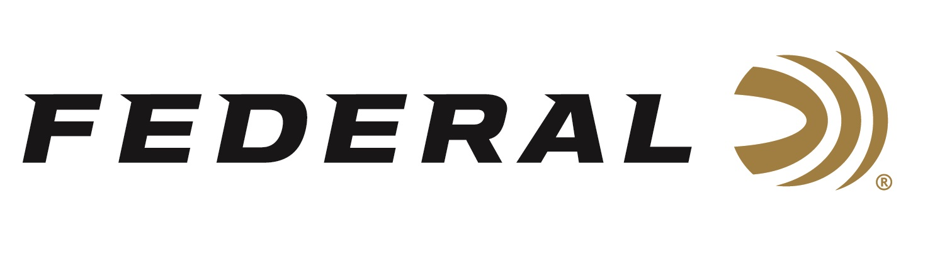

FOR IMMEDIATE RELEASE

Sporting Arms and Ammunition Manufacturers' Institute Publishes Accepted 12-gauge 1 ¾-inch Cartridge and Chamber Designs

ANOKA, Minnesota – September 11, 2019 – Federal recently presented its 12-gauge 1 ¾-inch Smooth Bore Barrel cartridge and chamber designs to the Sporting Arms and Ammunition Manufacturers' Institute (SAAMI) to be voted on for standardization. The specifications were approved and accepted as an official new cartridge recognized by the organization. Technical data and drawings of the newly accepted 12-gauge
1 ¾-inch SAAMI Standards are now published and available to the industry as a whole, as well as to the public.

“This is big news for our new Shorty Shotshell ammunition,” said Federal’s Shotshell Product Director Rick Stoeckel. “The 12-gauge 1 ¾-inch cartridge has been around for more than a decade, but it was never brought to SAAMI to be considered by its Technical Committee. Once we decided to start manufacturing this load, we immediately submitted it to SAAMI for industry standardization. We’re excited about this approval and we deeply appreciate SAAMI’s support.”

Federal’s new Shorty Shotshells deliver similar full-sized performance without the length of standard shells. Although just 1 ¾-inch long, new Shorty shotshells offer similar patterns, energy and accuracy as full-size counterparts. Now available in 8 shot, 4 buck and rifled slug loads perfect for fun at the range.

“SAAMI’s approval of the cartridge was a crucial step in legitimizing it within the industry,” continued Stoeckel. “Their work creates industry standards for the cartridge, and will hopefully inspire shotgun manufacturers to purposely build pump-action and semi-auto shotguns to specifically run 1 ¾-inch loads.”

SAAMI allows free access to technical data and drawings for accepted cartridge and chamber designs. These are posted within New SAAMI Cartridge & Chamber Designs under their Technical Information section, found at www.saami.org. A direct link to the 12-gauge 1 ¾-inch Smooth Bore Barrel Cartridge .PDF document can be viewed here: https://saami.org/technical-information/new-cartridge-chamber-drawings/.

SAAMI was founded in 1926 at the request of the federal government and tasked with creating and publishing industry standards for safety, interchangeability, reliability and quality, as well as coordinating technical data. SAAMI’s Technical Committee, which consists of firearm and ammunition industry experts, reviewed the 1 ¾-inch, 12-gauge cartridge submission over a period of several months. The official cartridge name, maximum cartridge and minimum chamber dimensions, pressure limits, test equipment, and other characteristics are all considered and scrutinized during the process.

For more information on Federal ammunition, visit www.federalpremium.com.

Press Release Contact: JJ Reich
Senior Communications Manager - Ammunition
E-mail: VistaPressroom@VistaOutdoor.com

About Federal Ammunition
Federal, headquartered in Anoka, MN, is a brand of Vista Outdoor Inc., an outdoor sports and recreation company. From humble beginnings nestled among the lakes and woods of Minnesota, Federal Ammunition has evolved into one of the world's largest producers of sporting ammunition. Beginning in 1922, founding president, Charles L. Horn, paved the way for our success. Today, Federal carries on Horn's vision for quality products and service with the next generation of outdoorsmen and women. We maintain our position as experts in the science of ammunition production. Every day we manufacture products to enhance our customers' shooting experience while partnering with the conservation organizations that protect and support our outdoor heritage. We offer thousands of options in our Federal Premium and Federal lines—it’s what makes us the most complete ammunition company in the business and provides our customers with a choice no matter their pursuit.

###

