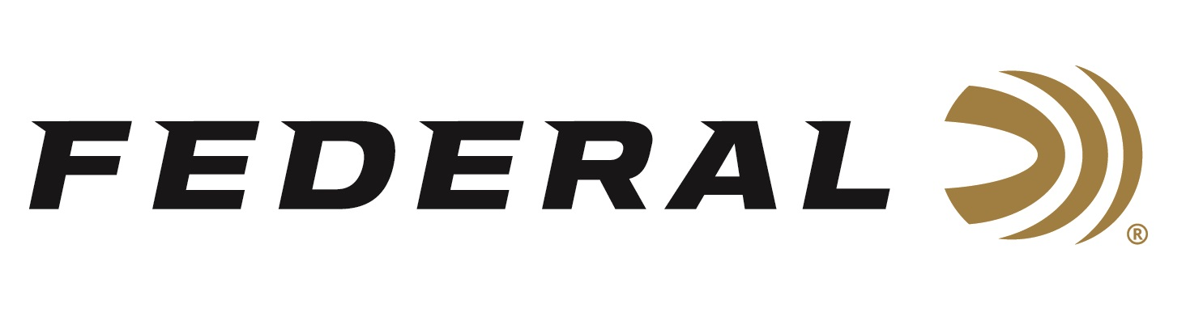

FOR IMMEDIATE RELEASE

Federal Ammunition Sponsored Athletes Earn Key Wins at the Championship of the Americas

ANOKA, Minnesota – November 14, 2018 – Federal Premium Ammunition sponsored shooters and brand ambassadors Kayle Browning and Ashley Carroll each earned gold medal victories at the Championship of the Americas in Guadalajara, Mexico, November 2 to 10, 2018.

This year’s Championship of the Americas was a key qualification event on the Road to the Tokyo 2020 Olympic Games for members of the USA Shooting Team. Olympic and Pan American Games quotas were on the line for shooting athletes from North and South America.

Browning earned one of those quota spots competing in Women’s Trap after shooting to a victory last Monday. Carroll earned the bronze medal after shooting the top Qualification score.

In the final, Browning hit 45 of 50 targets for the win which crowned her as gold-medal champion. The quota Browning earned is essentially a country’s ticket to participate in a specific event in the 2020 Olympic Games in Tokyo, Japan. In Shooting competition at the Olympic Games, a country can earn up to two quotas in a qualified event – but that doesn’t guarantee a specific athlete to compete in the Games, just that his/her country has a spot to do so.

A day later after earning her bronze, Carroll was back on the podium, but two places higher, as she teamed with Grayson Davey to earn gold in the Mixed Team Trap event.

Federal brand ambassador and reigning World Champion Caitlin Connor finished fourth in Women’s Skeet while another Federal athlete, Jake Wallace, finished 14th.

Serious shooters have long relied on Federal Premium Gold Medal shotshells to dominate the competition in trap, skeet and sporting clay events worldwide. Year after year, Gold Medal rounds have broken world records and won top honors at prestigious shoots like the World Cup and ATA Grand American, earning the respect of all levels of competitive shooters. The enhanced design of new Gold Medal Grand shotshells, introduced in 2017, builds on that tradition with less felt recoil, more reliable ignition, improved patterns, harder shot and maximum downrange power.

Federal recently became the official shotshell ammunition sponsor and supplier of USA Shooting, a non-profit organization that promotes the shooting sports and prepares American athletes to bring home Olympic gold. Learn more about USA Shooting at: www.usashooting.org. For more information on Federal ammunition, visit www.federalpremium.com.

Press Release Contact: JJ Reich
Senior Communications Manager - Firearms and Ammunition
E-mail: VistaPressroom@VistaOutdoor.com

About Federal Ammunition
Federal, headquartered in Anoka, MN, is a brand of Vista Outdoor Inc., an outdoor sports and recreation company. From humble beginnings nestled among the lakes and woods of Minnesota, Federal Ammunition has evolved into one of the world's largest producers of sporting ammunition. Beginning in 1922, founding president, Charles L. Horn, paved the way for our success. Today, Federal carries on Horn's vision for quality products and service with the next generation of outdoorsmen and women. We maintain our position as experts in the science of ammunition production. Every day we manufacture products to enhance our customers' shooting experience while partnering with the conservation organizations that protect and support our outdoor heritage. We offer thousands of options in our Federal Premium and Federal® lines-it's what makes us the most complete ammunition company in the business and provides our customers with a choice no matter their pursuit.

