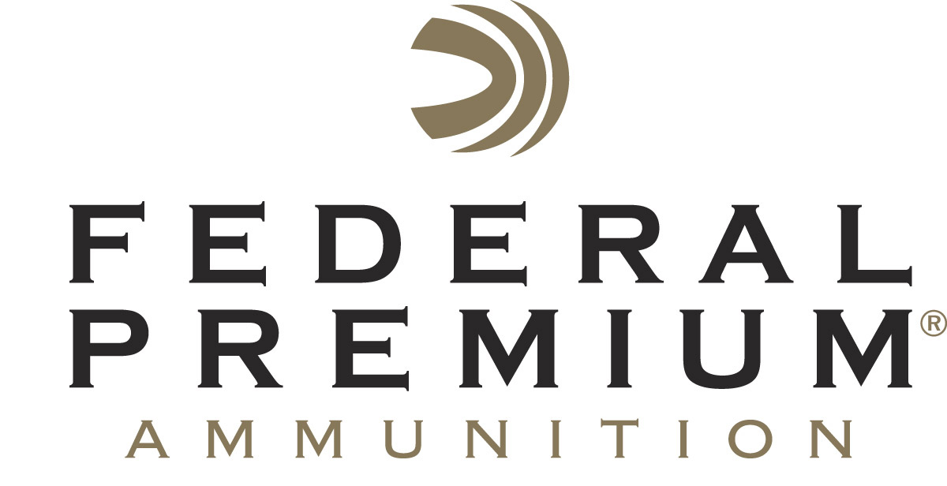
Contact: JJ Reich
Communications Manager
Firearms and Ammunition
(763) 323-3862
FOR IMMEDIATE RELEASE E-mail: pressroom@vistaoutdoor.com

Federal Premium Signs Vincent Hancock as Brand Ambassador

ANOKA, Minnesota – May 21, 2018 – Federal Premium Ammunition is pleased to announce it has partnered with champion skeet shooter Vincent Hancock. The two-time Olympic gold medalist will showcase Federal Premium ammunition as a sponsored shooter and serve as a brand ambassador.

“We are honored and extremely excited to welcome Vincent to our team,” said Federal Premium Marketing Director Jason Nash. “He is a true world-class shooter, patriot and promoter of the shooting sports, whose commitment to excellence and competitive shooting are a perfect fit for Federal Premium.”

Hancock is a three-time World Champion, the first American shotgun athlete ever to do so. His impressive shooting resume also includes two Olympic gold medals, nine World Cup gold medals and two golds at the Pan American Games. He is also a decorated military veteran. Hancock served as a sergeant in the U.S. Army Marksmanship Unit and was awarded two Meritorious Service Medals, National Defense Service Medal, Global War on Terrorism Service Medal, Army Service Ribbon and Distinguished International Shooter Badge.

As part of his new partnership with Federal Premium, Hancock will exclusively use the company’s ammunition in competitions and training. He will also make public appearances, assist with videos and photography, and support the company’s diverse social media marketing channels.

The promotional duties dovetail with Hancock’s personal goals. “You get out of this sport what you put into it,” he said. “And I want every kid out there to know that they can do anything.”

Hancock will also serve as the face of Federal Premium’s support for USA Shooting, a non-profit organization that promotes the shooting sports and prepares American athletes to bring home Olympic gold. Federal Premium recently became the official shotshell ammunition sponsor and supplier of USA Shooting.

Federal Premium is a brand of Vista Outdoor Inc., an outdoor sports and recreation company. For more information on Federal Premium, go to www.federalpremium.com.

About Vista Outdoor
Vista Outdoor is a leading global designer, manufacturer and marketer of consumer products in the growing outdoor sports and recreation markets. The company operates in two segments, Shooting Sports and Outdoor Products, and has a portfolio of well-recognized brands that provides consumers with a wide range of performance-driven, high-quality and innovative products for individual outdoor recreational pursuits. Vista Outdoor products are sold at leading retailers and distributors across North America and worldwide. Vista Outdoor is headquartered in Utah and has manufacturing operations and facilities in 13 U.S. States, Canada, Mexico and Puerto Rico along with international customer service, sales and sourcing operations in Asia, Australia, Canada, and Europe. For news and information, visit www.vistaoutdoor.com or follow us on Twitter @VistaOutdoorInc and Facebook at www.facebook.com/vistaoutdoor.

###

