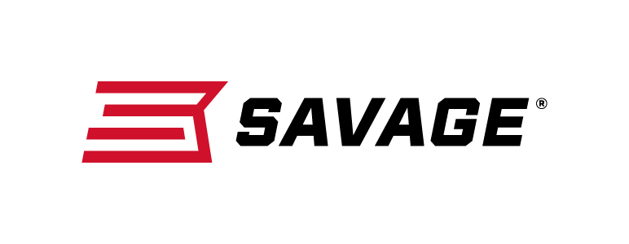
Contact: JJ Reich
Communications Manager
Firearms and Ammunition
(763) 323-3862
FOR IMMEDIATE RELEASE E-mail: pressroom@vistaoutdoor.com

New Savage 110 Brush Hunter Stops the Toughest Game in Its Tracks

Westfield, Massachusetts – March 29, 2018 – The new 110 Brush Hunter from Savage is built to beat the toughest hunting conditions and stop the biggest game in its tracks. Shipments of these firearms are currently being delivered to dealers.

Length-of-pull is easily customized to fit any shooter for comfort and consistency, and the user- adjustable AccuTrigger provides a light, crisp pull. The rifle is built on Savage’s time-tested 110 platform but with a modern design and improved ergonomics.

Its 20-inch, stainless steel, medium-contour barrel is threaded with an end cap and cradled securely within a rugged synthetic stock. As a bonus to hunters pursuing big game in close quarters, the 7.38-pound rifle’s oversize bolt handle and dependable iron sights are perfect for making fast shots count.

Features & Benefits
- Adjustable length-of-pull
- User-adjustable AccuTrigger
- New Model 110 design and ergonomics
- Black synthetic stock
- 20-inch stainless steel barrel threaded with an end cap
- Adjustable iron sights
- Detachable box magazine

Part No. / Description / MSRP
57043 / 338 Win. Mag., 20-inch barrel / $784
57044 / 375 Ruger, 20-inch barrel / $784
Learn more about Savage, visit www.savagearms.com.

About Savage
Headquartered in Westfield, Massachusetts for more than 100 years, Savage is one of the world's largest manufacturers of hunting, competition and self-defense centerfire and rimfire rifles, and shotguns. Their firearms are best known for accuracy and value. The entrepreneurial spirit that originally defined the company is still evident in its ongoing focus on continuous innovations, craftsmanship, quality and service.

###

