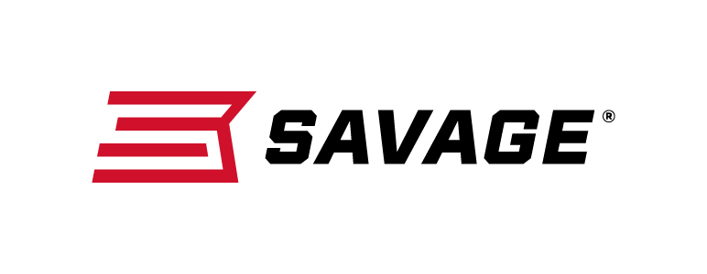
Contact: JJ Reich
Communications Manager
Firearms and Ammunition
(763) 323-3862
FOR IMMEDIATE RELEASE E-mail: pressroom@vistaoutdoor.com

Savage Gives Hunters Field-Ready Combo Package
with New 110 Engage Hunter XP

Westfield, Massachusetts – February 15, 2018 – Savage is pleased to offer hunters and other serious shooters a new field-ready rifle-and-optics package that combines the company’s proven Model 110 platform with a factory-mounted, bore-sighted Bushnell Engage scope. Shipments of these firearms are currently being delivered to dealers.

Length-of-pull on the 110 Engage Hunter XP is easily customized to fit any shooter for comfort and consistency, and the user-adjustable AccuTrigger provides a light, crisp pull. The rifle’s improved ergonomics get even more accuracy from its legendary 110 action, floating bolt head, and thread-in, zero-tolerance headspace system, while the optic’s drop-compensating reticle makes it easier to place precise shots at longer ranges.

Features & Benefits
- Adjustable length-of-pull
- User-adjustable AccuTrigger
- New Model 110 design and ergonomics
- Detachable box magazine
- Black synthetic stock
- Matte blued barrel
- Weaver Grand Slam rings and bases
- Bushnell Engage 3-9x40mm scope with drop-compensating reticle, mounted and boresighted

Part No. / Description / MSRP
57010 / 243 Win., 22-inch barrel / $629
57011 / 6.5 Creedmoor, 22-inch barrel / $629
57012 / 7mm-08 Rem., 22-inch barrel / $629
57013 / 260 Rem., 22-inch barrel / $629
57014 / 308 Win., 22-inch barrel / $629
57015 / 270 WSM, 24-inch barrel / $629
57016 / 300 WSM, 24-inch barrel / $629
57017 / 338 Federal, 22-inch barrel / $629
57027 / 25-06 Rem., 22-inch barrel / $629
57028 / 270 Win. 22-inch barrel / $629
57029 / 6.5X284 NORMA, 24-inch barrel / $629
57030 / 30-06 Sprg., 22-inch barrel / $629
57031 / 7mm Rem. Mag., 24-inch barrel / $629
57032 / 300 Win. Mag., 24-inch barrel / $629
57033 / 338 Win. Mag., 24-inch barrel / $629
57144 / 280 Ackley Improved, 22-inch barrel / $629

Learn more about Savage, visit www.savagearms.com.

About Savage
Headquartered in Westfield, Massachusetts for more than 100 years, Savage is one of the world's largest manufacturers of hunting, competition and self-defense centerfire and rimfire rifles, and shotguns. Their firearms are best known for accuracy and value. The entrepreneurial spirit that originally defined the company is still evident in its ongoing focus on continuous innovations, craftsmanship, quality and service.

###

