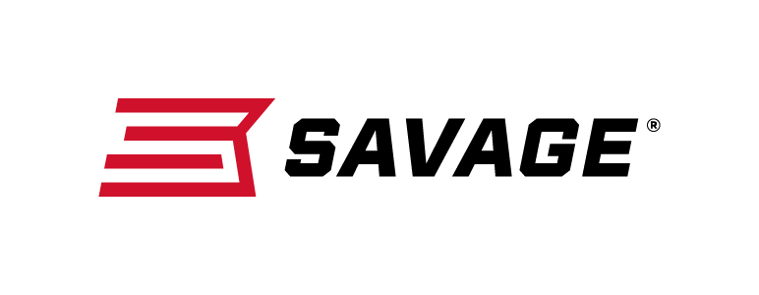
Contact: JJ Reich
Communications Manager
Firearms and Ammunition
(763) 323-3862
FOR IMMEDIATE RELEASE E-mail: pressroom@vistaoutdoor.com

Savage 110 Long Range Hunter Is a Perfect Fit
For Bringing Down Trophies at Extreme Distances

Westfield, Massachusetts – March 15, 2018 – Making a long-distance shot on the trophy of a lifetime requires not only a rifle built for extreme accuracy, but a rifle built for you. The easy-to-customize, incredibly accurate Savage 110 Long Range Hunter is up to the challenge. Shipments of these firearms are currently being delivered to dealers.

The Savage 110 Long Range Hunter’s AccuFit system lets you easily customize the length-of-pull and comb height for a personalized fit, while the user-adjustable AccuTrigger offers a crisp, clean pull.

Together with the AccuStock, which secures the action three-dimensionally along its entire length, the 110 Long Range Hunter provides the fit and function of a custom rifle—right out of the box. Plus, its 26-inch button rifled barrel provides the utmost precision and consistency, and is topped with a muzzle brake.

A long list of caliber options also include 280 Ackley Improved and 338 Lapua Mag.

Features & Benefits
- AccuFit system lets shooters quickly adjust comb height and length-of-pull
- User-adjustable AccuTrigger
- AccuStock rail system secures the action three-dimensionally along its entire length
- Gray synthetic stock
- 26-inch button-rifled barrel with Savage proprietary muzzle brake
- Hinged floorplate magazine (detachable box magazine on 338 Lapua Magnum)
- Soft grip overmold fore-end and pistol grip surfaces
- New Model 110 design and ergonomics

Part No. / Description / MSRP
57021 / 6.5 Creedmoor, 26-inch barrel / $1,099
57022 / 260 Rem., 26-inch barrel / $1,099
57023 / 308 Win., 26-inch barrel / $1,099
57024 / 300 WSM., 26-inch barrel / $1,099
57025 / 338 Federal, 26-inch barrel / $1,099
57034 / 6.5X284 Norma, 26-inch barrel / $1,099
57035 / 7mm Rem. Mag., 26-inch barrel / $1,099
57036 / 300 Win. Mag., 26-inch barrel / $1,099
57147 / 280 Ackley Improved, 26-inch barrel / $1,099
57037 / 338 Lapua Mag., 26-inch barrel / $1,299

Learn more about Savage, visit www.savagearms.com.

About Savage
Headquartered in Westfield, Massachusetts for more than 100 years, Savage is one of the world's largest manufacturers of hunting, competition and self-defense centerfire and rimfire rifles, and shotguns. Their firearms are best known for accuracy and value. The entrepreneurial spirit that originally defined the company is still evident in its ongoing focus on continuous innovations, craftsmanship, quality and service.

###

