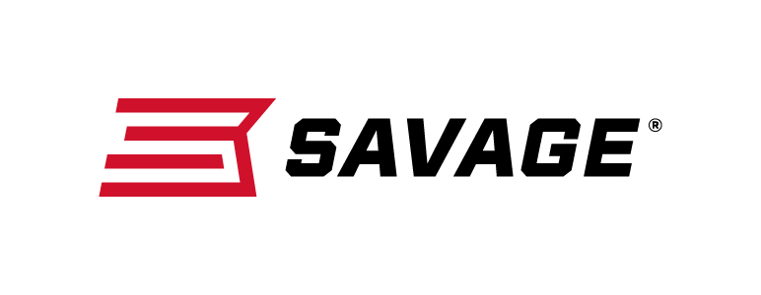
Contact: JJ Reich
Communications Manager
Firearms and Ammunition
(763) 323-3862
FOR IMMEDIATE RELEASE E-mail: pressroom@vistaoutdoor.com

Savage 110 Storm Extends Hunters’ Range and Conquers Extreme Weather

Westfield, Massachusetts – February 21, 2018 – Savage’s new Model 110 Storm allows hunters to conquer hunting’s most punishing weather while extending their effective range. Shipments of these firearms are currently being delivered to dealers.

The rugged rifle’s AccuFit system lets the shooter customize length-of-pull and comb height for comfort and consistency, and the user-adjustable AccuTrigger provides a light, crisp pull.

Together with the AccuStock, which secures the action three-dimensionally along its entire length, the 110 Storm provides the fit and function of a custom rifle—right out of the box. The rifle is built on Savage’s time-tested 110 platform but with a modern design and improved ergonomics. Available in a wide variety of right- and left-hand models.

Features & Benefits
- AccuFit system lets shooters quickly adjust comb height and length-of-pull
- User-adjustable AccuTrigger
- AccuStock rail system secures the action three-dimensionally along its entire length
- Detachable box magazine
- Stainless steel barreled action
- Gray synthetic stock
- Soft grip overmold fore-end and pistol grip surfaces
- New Model 110 design and ergonomics
- Drilled and tapped for scope mounts

Part No. / Description / MSRP
110 Storm
57076 / 223 Rem., 22-inch barrel / $849
57081 / 22-250 Rem., 22-inch barrel / $849
57082 / 243 Win., 22-inch barrel / $849
57077 / 6.5 Creedmoor, 22-inch barrel / $849
57083 / 7mm-08 Rem., 22-inch barrel / $849
57078 / 308 Win., 22-inch barrel / $849
57079 / 270 WSM., 24-inch barrel / $849
57084 / 300 WSM., 24-inch barrel / $849
57080 / 338 Federal, 22-inch barrel / $849
57050 / 25-06 Rem., 22-inch barrel / $849
57051 / 6.5 X284 Norma, 24-inch barrel / $849
57052 / 270 Win., 22-inch barrel / $849
57053 / 30-06 Sprg., 22-inch barrel / $849
57054 / 7mm Rem. Mag., 24-inch barrel / $849
57055 / 300 Win. Mag., 24-inch barrel / $849
57049 / 338 Win. Mag., 24-inch barrel / $849
57146 / 280 Ackley Improved, 22-inch barrel / $849

110 Storm Left Hand
57085 / 223 Rem., 22-inch barrel / $849
57087 / 22-250 Rem., 22-inch barrel / $849
57086 / 243 Win., 22-inch barrel / $849
57088 / 7mm-08 Rem., 22-inch barrel / $849
57089 / 308 Win., 22-inch barrel / $849
57056 / 270 WSM., 24-inch barrel / $849
57057 / 30-06 Sprg., 22-inch barrel / $849
57058 / 7mm Rem. Mag., 24-inch barrel / $849
57059 / 300 Win. Mag., 24-inch barrel / $849

Learn more about Savage, visit www.savagearms.com.

About Savage
Headquartered in Westfield, Massachusetts for more than 100 years, Savage is one of the world's largest manufacturers of hunting, competition and self-defense centerfire and rimfire rifles, and shotguns. Their firearms are best known for accuracy and value. The entrepreneurial spirit that originally defined the company is still evident in its ongoing focus on continuous innovations, craftsmanship, quality and service.

###

