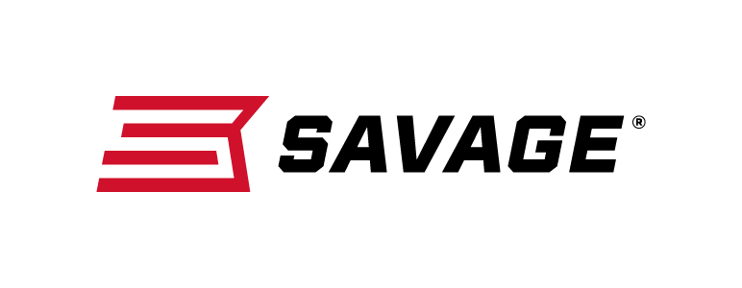
Contact: JJ Reich
Communications Manager
Firearms and Ammunition
(763) 323-3862
FOR IMMEDIATE RELEASE E-mail: pressroom@vistaoutdoor.com

Savage Introduces New Lineup of High-Performance 110 Tactical with AccuFit System

Westfield, Massachusetts – June 14, 2018 – When the stakes are high, settle for nothing less than the extreme precision, unflinching performance and industry-leading adaptability of the new Savage 110 Tactical. Caliber options include 308 Win, 6.5 Creedmoor and 6mm Creedmoor. Shipments of these firearms are currently being delivered to dealers.

The 110 Tactical’s revolutionary AccuFit system lets tactical and competitive shooters perfectly customize comb height and length-of-pull for the utmost consistency in all situations, while the user-adjustable AccuTrigger provides a light, crisp pull.

Together with the AccuStock, which secures the action three-dimensionally along its entire length, the 110 Tactical provides the fit and function of a custom rifle—right out of the box. It also features a suppressor-ready threaded barrel, a one-piece scope rail and 10-round detachable box magazine. Available in right- and left-hand models.

Features & Benefits
- AccuFit system lets shooters quickly adjust comb height and length-of-pull
- User-adjustable AccuTrigger
- AccuStock rail system secures the action three-dimensionally along its entire length
- Detachable 10-round Magpul AICS magazine
- Threaded heavy barrel with end cap
- 20 MOA EGW rail
- Gray or Desert Tan synthetic stock
- New Model 110 design and ergonomics
- Tactical oversized bolt handle

Part No. / Description / MSRP
110 Tactical (Gray)
57006 / 308 Win., 20-inch barrel / $784
57007 / 308 Win., 24-inch barrel / $784
57232 / 6.5 Creedmoor, 24-inch barrel / $784

110 Tactical LH (Left-Hand)
57009 / 308 Win., 24-inch barrel / $784

110 Tactical Desert (Desert Tan)
57008 / 6.5 Creedmoor, 24-inch barrel / $769
57137 / 6mm Creedmoor, 26-inch barrel / $769

Learn more about Savage, visit www.savagearms.com.

About Savage
Headquartered in Westfield, Massachusetts for more than 100 years, Savage is one of the world's largest manufacturers of hunting, competition and self-defense centerfire and rimfire rifles, and shotguns. Their firearms are best known for accuracy and value. The entrepreneurial spirit that originally defined the company is still evident in its ongoing focus on continuous innovations, craftsmanship, quality and service.

###

