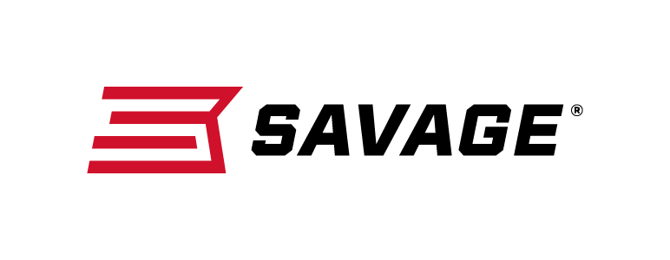
Contact: JJ Reich
Communications Manager
Firearms and Ammunition
(763) 323-3862
FOR IMMEDIATE RELEASE E-mail: pressroom@vistaoutdoor.com

Redesigned Savage AXIS II XP
Raises the Bar in Out-Of-The-Box Performance

Westfield, Massachusetts – February 12, 2018 – The redesigned AXIS II XP package rifle from Savage offers hunters even better out-of-the-box performance at the same affordable price, in a wide variety of full-size and compact models and a complete spectrum of popular hunting calibers. Shipments of these firearms are currently being delivered to dealers.

In addition to a new look with improved ergonomics, the AXIS II XP is loaded with features that deliver tack-driving accuracy on every shot, including the user-adjustable AccuTrigger, thread-in headspacing, and a factory-mounted, bore-sighted Bushnell Banner 3-9x40mm scope.

Features & Benefits

- User-adjustable AccuTrigger
- Improved ergonomics
- Button-rifled barrel
- Bushnell Banner 3-9x40mm scope
- Detachable box magazine
- Thread-in barrel headspacing

Part No. / Description / MSRP

AXIS II XP
57090 / 223 Rem., 22-inch barrel / $484
57091 / 22-250 Rem., 22-inch barrel / $484
57092 / 243 Win., 22-inch barrel / $484
57093 / 6.5 Creedmoor, 22-inch barrel / $484
57094 / 7mm-08 Rem., 22-inch barrel / $484
57095 / 308 Win., 22-inch barrel / $484
57096 / 25-06 Rem., 22-inch barrel / $484
57097 / 270 Win., 22-inch barrel / $484
57098 / 30-06 Sprg., 22-inch barrel / $484
57142 / 280 Ackley Improved, 22-inch barrel / $484

AXIS II XP COMPACT
57099 / 243 Win., 20-inch barrel / $484

AXIS II XP COMPACT MUDDY GIRL CAMO
57100 / 243 Win., 20-inch barrel / $539

AXIS II XP STAINLESS STEEL
57101 / 223 Rem., 22-inch barrel / $579
57102 / 22-250 Rem., 22-inch barrel / $579
57103 / 243 Win., 22-inch barrel / $579
57104 / 6.5 Creedmoor, 22-inch barrel / $579
57105 / 7mm-08 Rem., 22-inch barrel / $579
57106 / 308 Win., 22-inch barrel / $579
57107 / 25-06 Rem., 22-inch barrel / $579
57108 / 270 Win., 22-inch barrel / $579
57109 / 30-06 Sprg., 22-inch barrel / $579
57143 / 280 Ackley Improved, 22-inch barrel / $579

Learn more about Savage, visit www.savagearms.com.

About Savage
Headquartered in Westfield, Massachusetts for more than 100 years, Savage is one of the world's largest manufacturers of hunting, competition and self-defense centerfire and rimfire rifles, and shotguns. Their firearms are best known for accuracy and value. The entrepreneurial spirit that originally defined the company is still evident in its ongoing focus on continuous innovations, craftsmanship, quality and service.

###

