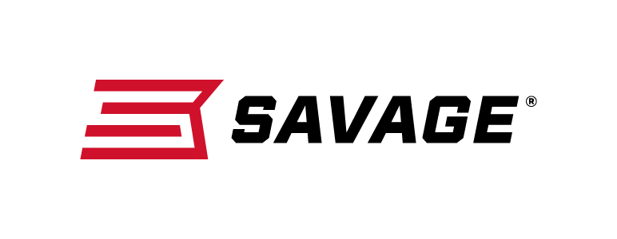
Contact: JJ Reich
Communications Manager
Firearms and Ammunition
(763) 323-3862
FOR IMMEDIATE RELEASE E-mail: pressroom@vistaoutdoor.com

Left Hand and Compact Models Join Savage’s Bolt-Action B Series

Westfield, Massachusetts – February 16, 2018 – Savage has expanded its B Series line of modern bolt-action rimfires with new left-handed and compact models built to fit smaller shooters. Shipments of these firearms are currently being delivered to dealers.

All B Series firearms have an ergonomically designed stock, higher comb, top tang safety and target-style, vertical pistol grip that allow shooters to hold the rifle in a more natural position that puts less pressure on the wrist.

Like the popular A Series rimfires, all B Series rifles feature a 10- round rotary magazine and the accuracy-boosting adjustable AccuTrigger. They also use thread-in zero tolerance headspacing similar to that found on Savage centerfire rifles to produce consistent accuracy.

Features & Benefits
- Now available in left-hand and compact models
- User-adjustable AccuTrigger
- 10-round rotary magazine
- Button-rifled barrel
- Modern, ergonomic composite stock
- Top tang safety
- Drilled and tapped for scope mounts
- Iron sights (22 LR only)

Part No. / Description / MSRP

B Series Left Hand
70840 / 17 HMR, 21-inch barrel / $299
70540 / 22 WMR, 21-inch barrel / $299
70240 / 22 LR, 21-inch barrel / $279

B Series Compact
70814 / 17 HMR, 18-inch barrel / $299
70514 / 22 WMR, 18-inch barrel / $299
70214 / 22 LR, 18-inch barrel / $279

Learn more about Savage, visit www.savagearms.com.

About Savage
Headquartered in Westfield, Massachusetts for more than 100 years, Savage is one of the world's largest manufacturers of hunting, competition and self-defense centerfire and rimfire rifles, and shotguns. Their firearms are best known for accuracy and value. The entrepreneurial spirit that originally defined the company is still evident in its ongoing focus on continuous innovations, craftsmanship, quality and service.

###

