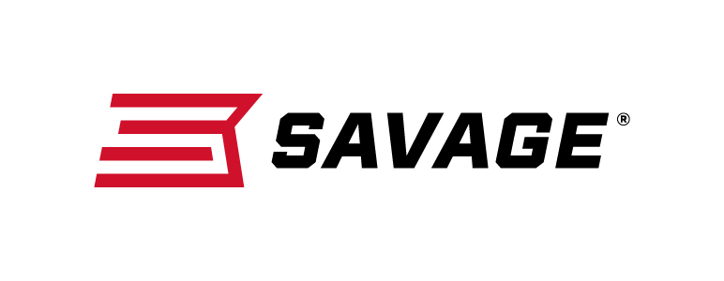
FOR IMMEDIATE RELEASE

Savage Introduces MSR 15 Competition

Westfield, Massachusetts – October 11, 2018 – Savage built the speed, accuracy and customization competitive shooters need to win into every aspect of its new MSR 15 Competition. Shipments of these firearms have been delivered to dealers.

The MSR 15 Competition is fitted with an advanced, 18-inch carbon fiber wrapped stainless barrel built specifically for the rifle in a collaborative effort between Savage and PROOF Research. Its unique ported muzzle brake allows the shooter to tune recoil impulse to stabilize the muzzle for faster, more accurate follow-up shots.

The custom-length gas block can be adjusted for optimal cycling of the full range of bullet weights, as well as for use with a suppressor. The gas block has also been upgraded with an integral Picatinny rail and a custom handguard.

Features & Benefits
- Savage by PROOF Research 18-inch carbon fiber wrapped stainless barrel
- Nickel-boron bolt carrier
- Custom-forged upper and lower receivers
- Non-reciprocating side charging handle
- Savage tunable muzzle brake
- Magpul CTR buttstock
- Two-stage trigger
- Custom-length adjustable gas system
- Rigid free-float handguard with M-LOK, anti-flare grooves and red QD sling mount
- Red ambidextrous selector, receiver end plate with QD mount, and removable custom mag well flare
- Ambidextrous magazine release
- Hogue pistol grip

Part No. / Description / MSRP
22938 / 223 Rem., 18-inch barrel / $2,875
22936 / 224 Valkyrie, 18-inch barrel / $2,875

Learn more about Savage, visit www.savagearms.com.

Press Release Contact: JJ Reich
Senior Communications Manager - Firearms and Ammunition
E-mail: VistaPressroom@VistaOutdoor.com

About Savage
Headquartered in Westfield, Massachusetts, for more than 100 years, Savage is one of the world's largest manufacturers of hunting, competition and self-defense centerfire and rimfire rifles, and shotguns. Their firearms are best known for accuracy and value. The entrepreneurial spirit that originally defined the company is still evident in its ongoing focus on continuous innovations, craftsmanship, quality and service.

###

