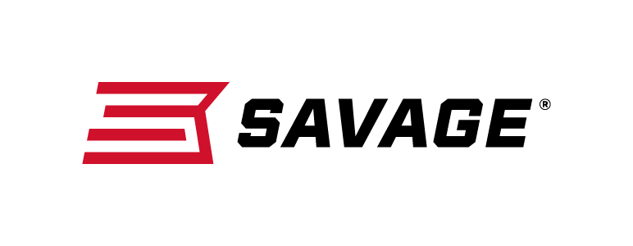
FOR IMMEDIATE RELEASE

Savage Boosts Performance of MSR 15 with Its Recon LRP

Westfield, Massachusetts – April 11, 2019 – Savage has added an adjustable gas block and longer barrel to stretch the out-of-the-box performance of its MSR 15 Recon platform even further. This popular long-range model was introduced to dealers in 2018, additional shipments continue to feed the marketplace.

The Recon LRP features an 18-inch barrel to optimize velocities and accuracy, and its gas block can be customized to specific ammunition for the best possible cycling. Like the original MSR 15 Recon, it comes standard with upgrades such as a two-stage trigger, free-float handguard and Savage barrel.

Its Melonite QPQ finish ensure the most consistent, accurate performance in any conditions, while the custom-forged lower receiver and Hogue pistol grip impart a look that stands out from the crowd.

Features
- Melonite QPQ 18-inch barrel
- Adjustable gas block (22 Nosler and .224 Valkyrie only)
- Custom-forged lower receiver
- Chambered in the hottest MSR 15 calibers, including 224 Valkyrie
- Magpul CTR buttstock
- Tunable muzzlebrake
- Two-stage trigger
- Mid-length gas system
- Free-float M-LOK handguard
- Hogue pistol grip

Part No. / Description / MSRP
22931 / 224 Valkyrie, 18-inch barrel / $1,249
22922 / 22 Nosler, 18-inch barrel / $1,249
22932 / 6.8 SPC, 18-inch barrel / $1,249

Learn more about Savage, visit www.savagearms.com.

Press Release Contact: JJ Reich
Senior Communications Manager - Firearms and Ammunition
E-mail: VistaPressroom@VistaOutdoor.com

About Savage
Headquartered in Westfield, Massachusetts for 125 years, Savage is one of the world's largest manufacturers of hunting, competition and self-defense centerfire and rimfire rifles, and shotguns. Their firearms are best known for accuracy and value. The entrepreneurial spirit that originally defined the company is still evident in its ongoing focus on continuous innovations, craftsmanship, quality and service.

###

