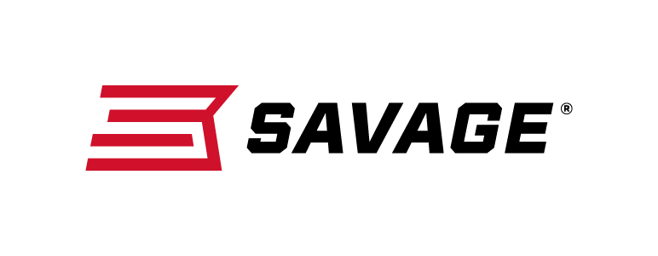
FOR IMMEDIATE RELEASE

New Savage Rascals Raise the Bar in Pint-Sized Performance

Westfield, Massachusetts – September 24, 2018 – Savage is pleased to take micro rimfire rifle performance to new heights with the new Rascal FV-SR (Suppressor Ready), Rascal Target and Rascal Target XP. Shipments of these firearms have been delivered to dealers.

The Rascal FV-SR enhances accuracy with a heavy barrel featuring a threaded (1/2-28) muzzle. Like the original Rascal, the single-shot rifle cocks by lifting the bolt and unloads easily—without pulling the trigger. The design also builds superior shooting skills thanks to full-size rifle features, including a peep sight, tough synthetic stock and Savage’s user-adjustable Accu-Trigger system. The two new suppressor-ready Rascal models are available in pink or black.

The new Rascal Target is built for accuracy and adaptability, thanks to a precision hardwood stock, heavy 16 1/8-inch barrel, one-piece Picatinny rail and threaded (1/2-28) muzzle. Like the Rascal FV-SR, the Rascal Target offers full-size rifle features, including Savage’s user-adjustable AccuTrigger system and suppressor-ready barrels. Collectively, the platform offers far better safety, functionality and accuracy than competing designs.

The Rascal Target XP offers all the Rascal Target amenities in a ready-to-shoot package that comes with a mounted and boresighted 4x32mm scope, as well as a bipod sling swivel stud mount. A left-hand model of this configuration is also available.

Rascal Target, Target XP Features & Benefits
- Precision hardwood stock
- 16 1/8-inch heavy barrel with threaded muzzle (Suppressor Ready)
- One-piece Picatinny rail
- Reliable, single-shot action
- Manual safety
- Unload without pulling the trigger
- Adjustable AccuTrigger
- Feed ramp
- Includes ear plugs and firearms lock
- 11-degree target crown
- 4x32mm scope (Rascal Target XP)
- Bipod sling swivel stud mount (Rascal Target XP)

Part No. / Description / MSRP
13834 / Rascal FV-SR Black, 22 S, L, LR, 16.125-inch barrel / $219
13835 / Rascal FV-SR Pink, 22 S, L, LR, 16.125-inch barrel / $219
13823 / Rascal Target, 22 S, L, LR, 16.125-inch barrel / $314
13824 / Rascal Target XP, 22 S, L, LR, 16.125-inch barrel / $399
13836 / Rascal Target XP LH, 22 S, L, LR, 16.125-inch barrel / $399

Learn more about Savage at: www.savagearms.com.

Press Release Contact: JJ Reich
Senior Communications Manager - Firearms and Ammunition
E-mail: VistaPressroom@VistaOutdoor.com

About Savage
Headquartered in Westfield, Massachusetts for more than 100 years, Savage is one of the world's largest manufacturers of hunting, competition and self-defense centerfire and rimfire rifles, and shotguns. Their firearms are best known for accuracy and value. The entrepreneurial spirit that originally defined the company is still evident in its ongoing focus on continuous innovations, craftsmanship, quality and service.

###

