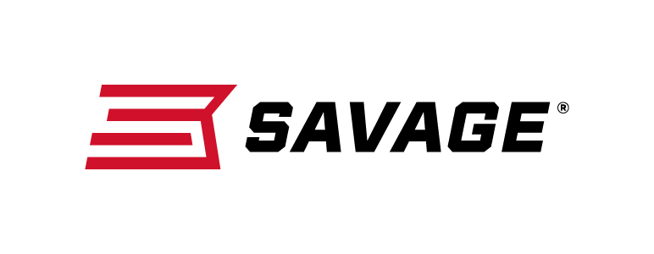
Contact: JJ Reich
Communications Manager
Firearms and Ammunition
(763) 323-3862
FOR IMMEDIATE RELEASE E-mail: pressroom@vistaoutdoor.com

New Savage 110 Lightweight Storm Offers Easy Handling and Dependable Performance in the Worst Weather Conditions

Westfield, Massachusetts – February 27, 2018 – The compact, flyweight design of the new Savage 110 Lightweight Storm offers the maneuverability to make the toughest shots in any situation coupled with the toughness to take on any weather. Shipments of these firearms are currently being delivered to dealers.

Length-of-pull is easily customized to fit the shooter for comfort and consistency, and the user-adjustable AccuTrigger provides a light, crisp pull. The rifle is built on Savage’s time-tested 110 platform, but with a modern design and improved ergonomics.

Its detachable box magazine, stainless steel action, and 20-inch stainless steel barrel stand up to punishment from the most brutal conditions, yet tips the scales at a mere 5.65 pounds.

Features & Benefits
- Adjustable length-of-pull
- User-adjustable AccuTrigger
- New Model 110 design and ergonomics
- Detachable box magazine
- Spiral-fluted bolt
- 20-inch stainless steel lightweight contour barrel
- Rugged synthetic stock
- Skeletonized receiver

Part No. / Description / MSRP
57071 / 223 Rem., 20-inch barrel / $749
57072 / 7mm-08 Rem., 20-inch barrel / $749
57073 / 308 Win., 20-inch barrel / $749
57074 / 243 Win., 20-inch barrel / $749
57075 / 6.5 Creedmoor, 20-inch barrel / $749
57048 / 270 Win., 20-inch barrel / $749

Learn more about Savage, visit www.savagearms.com.

About Savage
Headquartered in Westfield, Massachusetts for more than 100 years, Savage is one of the world's largest manufacturers of hunting, competition and self-defense centerfire and rimfire rifles, and shotguns. Their firearms are best known for accuracy and value. The entrepreneurial spirit that originally defined the company is still evident in its ongoing focus on continuous innovations, craftsmanship, quality and service.

###

