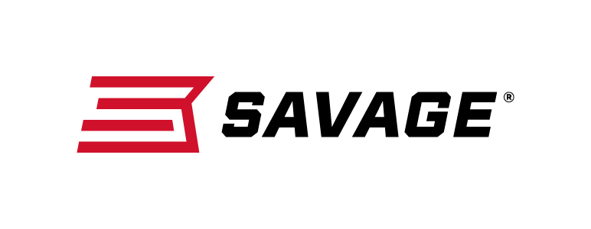
Contact: JJ Reich
Sr. Communications Manager
Firearms and Ammunition
(763) 323-3862
FOR IMMEDIATE RELEASE E-mail: pressroom@vistaoutdoor.com

Gun World Magazine Honors Savage Employee with Feature Story
Highlighting Company’s Commitment to Excellence

Westfield, Massachusetts – July 13, 2018 – Longtime Savage employee Debbie Yale is the focus of a feature story in the August 2018 issue of Gun World magazine. The article chronicles Yale’s illustrious 35-year career in the firearms industry and highlights Savage’s commitment to excellence.

Author Becky Yackley explores the underpinnings of Yale’s interest in firearms, along with the work ethic and positive attitude that fueled her rise from machine operator to production manager of Savage’s Lakefield, Ontario, factory, which employs about 130 people.

“Debbie’s contagious, can-do spirit has been a driving force throughout her successful career,” said Savage’s Senior Manager of Marketing Beth Shimanski. “Her passion for creating high-quality firearms has also been a perfect fit for Savage’s dedication to reliability and performance.”

As the story “Savage Debbie” reveals, Yale’s interest in firearms was sparked by curiosity about her brothers’ .22 rifle. At the tender age of 9, she was so fascinated by the gun’s inner workings that she gladly volunteered to clean it—a chore the boys were more than willing to let her handle.

When she started at what was then Lakefield Arms in 1984, her first job was making the front of a rifle bolt, a task that required 13 different steps on separate machines. A quick study, Yale soon worked on a variety of other components, with a steadily expanding arsenal of tools and machines. Her skills and spirit led to her promotion to “lead hand” in 1990, then shift supervisor four years later. In 2001, she became the plant’s manufacturing supervisor and was promoted to production manager in 2013.

Shimanski also credits Yale’s ability to bring out the best in people for her success. “Debbie is a shining example of Savage’s time-tested approach to building solid production lines by nurturing the passion and careers of our employees through a combination of teamwork, mentoring and recognition,” she said.

The Summer 2018 edition of Gun World is currently on newsstands nationwide. Learn more at www.gunworld.com.

For 2018, Savage’s commitment to excellence is highlighted by the company’s release of their newest addition to their A22 rimfire rifle series—the new A22 FSS. The semiautomatic 22 LR upgrades the original A22 platform with a 22-inch stainless steel sporter barrel, as well as two-piece bases. It features a gray synthetic stock, user adjustable AccuTriggerand reliable straight-blowback action. Accuracy, reliability and durability all come together in the A22 Stainless from Savage.

To learn more about Savage and many new products, including the AccuFit system, visit www.savagearms.com.

About Savage
Headquartered in Westfield, Massachusetts, for more than 120 years, Savage is one of the world's largest manufacturers of hunting, competition and self-defense centerfire and rimfire rifles, and shotguns. Their firearms are best known for accuracy and value. The entrepreneurial spirit that originally defined the company is still evident in its ongoing focus on continuous innovations, craftsmanship, quality and service.

###

