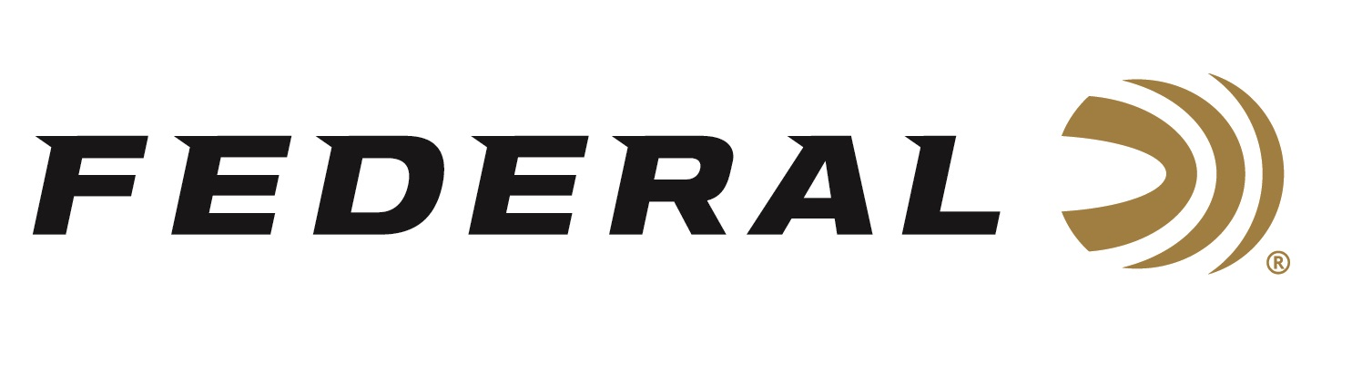

FOR IMMEDIATE RELEASE

Federal’s New 224 Valkyrie Loads Stretch Long-Range Horizons

ANOKA, Minnesota – August 22, 2019 – Federal proudly announces two new flat-shooting Premium 224 Valkyrie loads that deliver precision accuracy at long ranges. Shipments of these Federal Premium 224 Valkyrie cartridges have been delivered to dealers.

In 2018, Federal transformed the MSR 15 platform and broke all boundaries of ballistic performance by introducing the 224 Valkyrie cartridge. Now, it’s giving hunters and shooters new loads that stretch the cartridge’s capabilities even farther: 80.5-grain Gold Medal Berger Hybrid and 78-grain Barnes Triple-Shock X.

Like all 224 Valkyrie offerings, the new loads provide extremely flat trajectories and match accuracy at extreme ranges. They offer significantly less wind drift and drop than other loads in their class, as well as less than half the recoil of cartridges with comparable ballistics.

"The 224 Valkyrie cartridge's dramatically improved trajectories over all other MSR 15 cartridges, including the 22 Nosler, 223 Rem. and 6.5 Grendel—with less recoil of larger cartridges offering comparable ballistics, such as the 6.5 Creedmoor,” said Federal Centerfire Product Director Mike Holm. “And with the full array of high-performance projectiles available, it’s poised to deliver on virtually every shooter’s needs. For those looking for something new, different and better from their AR-15 platform, the 224 Valkyrie is it.”

Features & Benefits
- New Berger Hybrid and Barnes TSX bullet offerings
- Least wind drift and drop in the category
- Significantly less recoil than other cartridges with comparable ballistics
- Better ballistic performance than any other MSR 15 cartridge
- Superb accuracy and extreme long-range performance in bolt-action rifles

Part No. / Description / MSRP
GM224VLKBH2 / 224 Valkyrie 80.5 grain Gold Medal Berger Hybrid / $32.95
P224VLKBTSX1 / 224 Valkyrie 78 grain Barnes TSX / $35.95

For more information on Federal ammunition, visit www.federalpremium.com.
Press Release Contact: JJ Reich
Senior Communications Manager - Ammunition
E-mail: VistaPressroom@VistaOutdoor.com

About Federal Ammunition
Federal, headquartered in Anoka, MN, is a brand of Vista Outdoor Inc., an outdoor sports and recreation company. From humble beginnings nestled among the lakes and woods of Minnesota, Federal Ammunition has evolved into one of the world's largest producers of sporting ammunition. Beginning in 1922, founding president, Charles L. Horn, paved the way for our success. Today, Federal carries on Horn's vision for quality products and service with the next generation of outdoorsmen and women. We maintain our position as experts in the science of ammunition production. Every day we manufacture products to enhance our customers' shooting experience while partnering with the conservation organizations that protect and support our outdoor heritage. We offer thousands of options in our Federal Premium and Federal lines—it’s what makes us the most complete ammunition company in the business and provides our customers with a choice no matter their pursuit.

###

