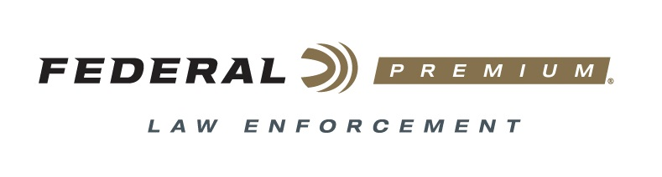

FOR IMMEDIATE RELEASE

Federal Premium Law Enforcement Offers BallistiClean
Frangible Slug & Buckshot

ANOKA, Minnesota – June 10, 2019 – Federal Premium Law Enforcement’s new BallistiClean frangible slug and buckshot loads let shooters train hard without making hard sacrifices. Shipments of the ammunition have been delivered to dealers.

BallistiClean frangible slug and buckshot loads provide uncompromising reliability and performance with Catalyst, the only 100 percent lead-free primer design proven as reliable as conventional lead styphnate primers. Combined with BallistiClean’s non-lead projectiles, which break up on impact with hard targets, the loads result in the safest shooting and most realistic, effective training.

Features & Benefits
- 100 percent lead-free Catalyst primer
- Primer compound is non-hygroscopic, has no shelf life limitations and easily ignites a large variety of shotshell powders
- Lead-free frangible slugs and buckshot reduce the amount of splash-back on steel targets
- Clean and consistent
- Provides ballistic performance and feel almost identical to duty loads
- 25-count boxes

Part No. / Description / MSRP
BC132 00 / 12 gauge 2 ¾-inch 9 Pellet 00 frangible buckshot, 1,600 fps / $39.99
BC127 RS / 12 gauge 2 ¾-inch 325-grain frangible rifled slug, 1,500 fps / $39.99

For more information on Federal ammunition, visit www.federalpremium.com.

Press Release Contact: JJ Reich
Senior Communications Manager - Ammunition
E-mail: VistaPressroom@VistaOutdoor.com

About Federal Ammunition
Federal, headquartered in Anoka, MN, is a brand of Vista Outdoor Inc., an outdoor sports and recreation company. From humble beginnings nestled among the lakes and woods of Minnesota, Federal Ammunition has evolved into one of the world's largest producers of sporting ammunition. Beginning in 1922, founding president, Charles L. Horn, paved the way for our success. Today, Federal carries on Horn's vision for quality products and service with the next generation of outdoorsmen and women. We maintain our position as experts in the science of ammunition production. Every day we manufacture products to enhance our customers' shooting experience while partnering with the conservation organizations that protect and support our outdoor heritage. We offer thousands of options in our Federal Premium and Federal lines—it’s what makes us the most complete ammunition company in the business and provides our customers with a choice no matter their pursuit.

Federal is part of Vista Outdoor Inc., an outdoor sports and recreation corporation. For news and information on Vista Outdoor Inc., visit www.vistaoutdoor.com.

###

