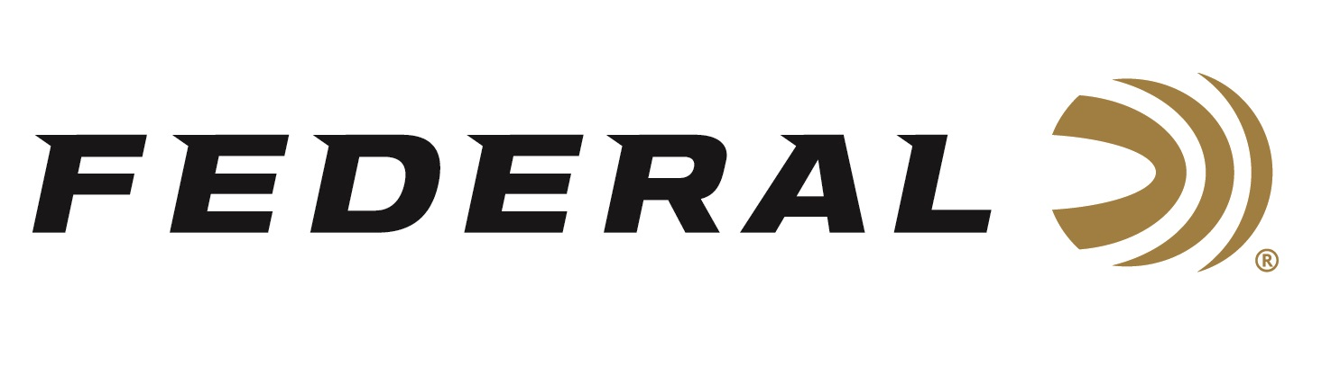

FOR IMMEDIATE RELEASE

Federal Unveils New Top Gun Loads for Sporting Clays Shooters

ANOKA, Minnesota – March 18, 2019 – Federal expands its venerable Top Gun target shotshell line with Top Gun Sporting, loads designed specifically for sporting clays shooters. Shipments have been delivered to dealers.

For decades, Top Gun has been pulverizing even the most challenging clay targets. Now shooters can get that same consistent, trusted performance with Top Gun Sporting loads. They push their payloads fast to shorten leads, yet reduce felt recoil to allow quicker follow-up shots. Available in 12, 20 and 28 gauge, as well as .410.

Features & Benefits
• Loads designed specifically for sporting clays shooters
• High velocities and less felt recoil
• Hard pellets
• Consistent, reliable Federal primer
• Unique wad column produces consistent patterns

Part No. / Description / MSRP
TGSF128 7.5 / 12 gauge 2 3/4 inch, 1 ounce, 1,330 fps, 7.5, 25-count / $8.95
TGSF128 8 / 12 gauge 2 3/4 inch 1 ounce, 1,330 fps, 8, 25-count / $8.95
TGS128 7.5 / 12 gauge 2 3/4 inch 1 ounce, 1,250 fps, 7.5, 25-count / $8.95
TGS128 8 / 12 gauge 2 3/4 inch 1 ounce, 1,250 fps, 8, 25-count / $8.95
TGS224 7.5 / 20 gauge 2 3/4 inch 7/8 ounce, 1,250 fps, 7.5, 25-count
TGS224 8 / 20 gauge 2 3/4 inch 7/8 ounce, 1,250 fps, 8, 25-count / $8.95
TGS2821 7.5 / 28 gauge 2 3/4 inch 3/4 ounce, 1,330 fps, 7.5, 25-count / $13.95
TGS2821 8 / 28 gauge 2 3/4 inch 3/4 ounce, 1,330 fps, 8, 25-count / $13.95
TGS2821 9 / 28 gauge 2 3/4 inch 3/4 ounce, 1,330 fps, 9, 25-count / $13.95
TGS41214 7.5 / .410 2 1/2 inch 1/2 ounce, 1,330 fps, 7.5, 25-count / $13.95
TGS41214 8 / .410 2 1/2 inch 1/2 ounce, 1,330 fps, 8, 25-count / $13.95
TGS41214 9 / .410 2 1/2 inch 1/2 ounce, 1,330 fps, 9, 25-count / $13.95

For more information on Federal ammunition, visit www.federalpremium.com.

Press Release Contact: JJ Reich
Senior Communications Manager - Ammunition
E-mail: VistaPressroom@VistaOutdoor.com

About Federal Ammunition
Federal, headquartered in Anoka, MN, is a brand of Vista Outdoor Inc., an outdoor sports and recreation company. From humble beginnings nestled among the lakes and woods of Minnesota, Federal Ammunition has evolved into one of the world's largest producers of sporting ammunition. Beginning in 1922, founding president, Charles L. Horn, paved the way for our success. Today, Federal carries on Horn's vision for quality products and service with the next generation of outdoorsmen and women. We maintain our position as experts in the science of ammunition production. Every day we manufacture products to enhance our customers' shooting experience while partnering with the conservation organizations that protect and support our outdoor heritage. We offer thousands of options in our Federal Premium and Federal lines—it’s what makes us the most complete ammunition company in the business and provides our customers with a choice no matter their pursuit.

Federal is part of Vista Outdoor Inc., an outdoor sports and recreation corporation. For news and information on Vista Outdoor Inc., visit www.vistaoutdoor.com.

###

