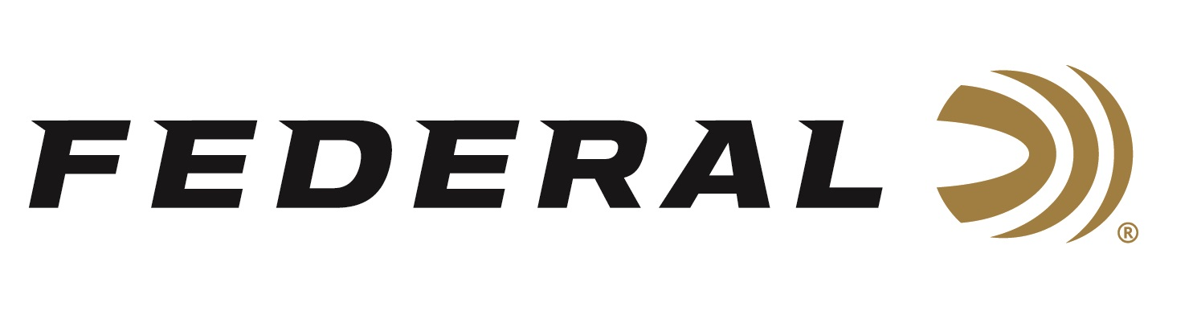

FOR IMMEDIATE RELEASE

Federal’s New Upland Steel Loads Are Perfect for High-Volume Hunts

ANOKA, Minnesota – August 19, 2019 – Federal is pleased to announce new Upland Steel loads in 12- and 20-gauge, which are perfect choices for doves and other light upland game, especially in areas that require the use of non-lead shot. Shipments of Federal Upland Steel ammunition have been delivered to dealers.

“This is an ultra-reliable, cost-effective, high-performance steel load offered in the smaller shot sizes that high-volume upland hunters are looking for,” said Federal Shotshell Product Director Rick Stoeckel. “For example, it’s definitely a great option for those who are required to shoot steel when hunting dove.”

With these new loads, doves are done. Federal Upland Steel serves up the patterns and power hunters need for hard-to-hit birds at a price that keeps them shooting all day. The loads are consistent and reliable, with high velocities that make the most of the steel payload.

Features
- Quality steel payloads
- High velocities
- Reliable performance
- Priced for fast-paced, high-volume dove hunts and other upland game

Part No. / Description / MSRP
USH12 6 / 12 gauge 2 3/4 inch 1 1/8 ounce, 6, 1400 fps, 25-count / $9.95
USH12 7.5 / 12 gauge 2 3/4 inch 1 1/8 ounce, 7.5, 1400 fps, 25-count / $9.95
USH20 6 / 20 gauge 2 3/4 inch ¾ ounce, 6, 1500 fps, 25-count / $8.95
USH20 7.5 / 20 gauge 2 3/4 inch ¾ ounce, 7.5, 1500 fps, 25-count / $8.95

For more information on Federal ammunition, visit www.federalpremium.com.

Press Release Contact: JJ Reich
Senior Communications Manager - Ammunition
E-mail: VistaPressroom@VistaOutdoor.com

About Federal Ammunition
Federal, headquartered in Anoka, MN, is a brand of Vista Outdoor Inc., an outdoor sports and recreation company. From humble beginnings nestled among the lakes and woods of Minnesota, Federal Ammunition has evolved into one of the world's largest producers of sporting ammunition. Beginning in 1922, founding president, Charles L. Horn, paved the way for our success. Today, Federal carries on Horn's vision for quality products and service with the next generation of outdoorsmen and women. We maintain our position as experts in the science of ammunition production. Every day we manufacture products to enhance our customers' shooting experience while partnering with the conservation organizations that protect and support our outdoor heritage. We offer thousands of options in our Federal Premium and Federal lines—it’s what makes us the most complete ammunition company in the business and provides our customers with a choice no matter their pursuit.

###

