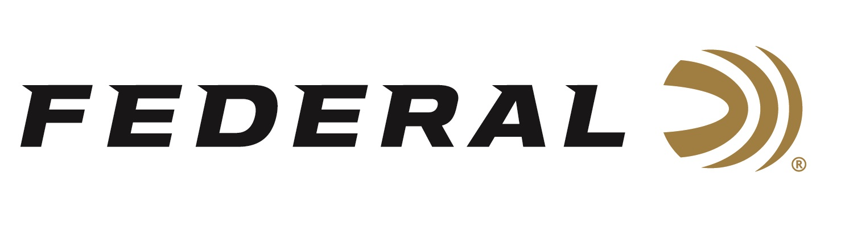

FOR IMMEDIATE RELEASE

Handloaders Can Make It Their Own With Fusion Component Bullets

ANOKA, Minnesota – March 29, 2019 – Federal is excited to announce new Fusion component bullets, which will let handloaders craft their own loads with the bullet design that forever changed hunting ammunition. Shipments have been delivered to dealers.

Fusion component bullets provide the largest expansion and highest weight retention in their class. With a molecularly fused jacket and a pressure-formed core, Fusion transfers maximum energy on target and provides tag-filling accuracy. Now available in a full array of the most popular bullet diameters and weights.

Features & Benefits
- Copper jacket is electro-chemically applied for perfect uniformity
- Tough, pressure-formed lead core
- Boat-tail design for excellent accuracy
- Skived, pre-programmed nose provides consistent expansion
- Maximum weight retention for deep penetration

Part No. / Description / MSRP
FB264F2 / 264 cal. 140-grain, 100-count / $31.95
FB277F2 / 277 cal. 130-grain, 100-count / $31.95
FB277F4 / 277 cal. 150-grain, 100-count / $33.95
FB284F1 / 284 cal. 140-grain, 100-count / $38.95
FB284F3 / 284 cal. 160-grain, 100-count / $38.95
FB284F4 / 284 cal. 175-grain, 100-count / $38.95
FB308F1 / 308 cal. 150-grain, 50-count / $20.95
FB308F4 / 308 cal. 180-grain, 50-count / $20.95
FB338F1 / 338 cal. 200-grain, 50-count / $23.95
FB338F2 / 338 cal. 225-grain, 50-count / $23.95

For more information on Federal ammunition, visit www.federalpremium.com.

Press Release Contact: JJ Reich
Senior Communications Manager - Ammunition
E-mail: VistaPressroom@VistaOutdoor.com

About Federal Ammunition
Federal, headquartered in Anoka, MN, is a brand of Vista Outdoor Inc., an outdoor sports and recreation company. From humble beginnings nestled among the lakes and woods of Minnesota, Federal Ammunition has evolved into one of the world's largest producers of sporting ammunition. Beginning in 1922, founding president, Charles L. Horn, paved the way for our success. Today, Federal carries on Horn's vision for quality products and service with the next generation of outdoorsmen and women. We maintain our position as experts in the science of ammunition production. Every day we manufacture products to enhance our customers' shooting experience while partnering with the conservation organizations that protect and support our outdoor heritage. We offer thousands of options in our Federal Premium and Federal lines—it’s what makes us the most complete ammunition company in the business and provides our customers with a choice no matter their pursuit.

Federal is part of Vista Outdoor Inc., an outdoor sports and recreation corporation. For news and information on Vista Outdoor Inc., visit www.vistaoutdoor.com.

###

