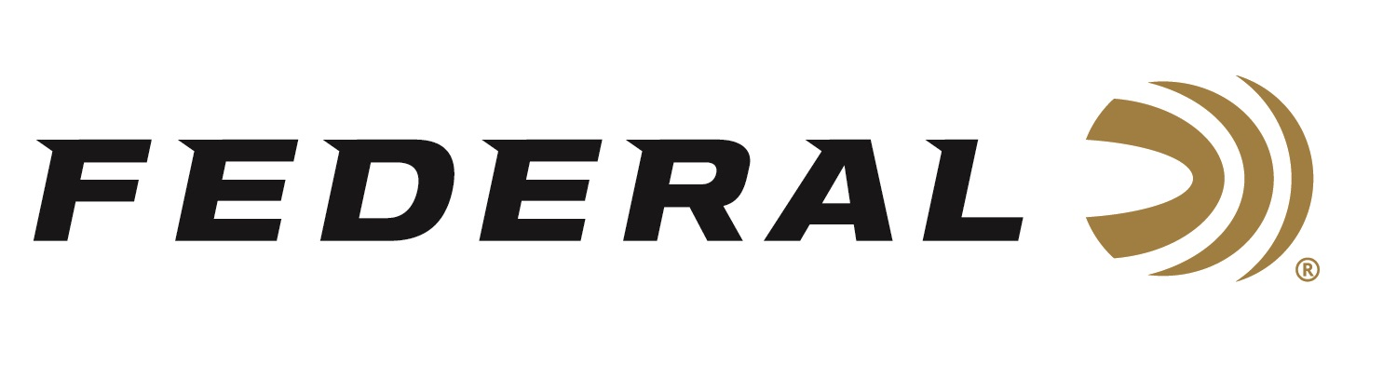

FOR IMMEDIATE RELEASE

Federal Unveils ‘New Look of Authority’ with Logo and Packaging Changes

ANOKA, Minnesota – January 7, 2019 – Federal, the world’s largest sporting ammunition manufacturer, is rolling out an exciting new look and feel as part of its continuing progression. The major shift, which the company calls “The New Look of Authority,” includes a new logo and complete packaging refresh.

The initiative gives Federal a fresh, modern logo. The simplified logo features a stronger, bolder font that’s customized to show motion and cutting-edge technology. It’s derived from the original Federal logo but has a contemporary feel with the iconic Shockwave logo. The new packaging designs use this new logo and all have a cohesive look throughout the entire product line.

“The font inspires strength, heritage and forward motion, both in the technology of our products and the attitude of our employees,” Vanderbrink said. “We’re always looking ahead, driving to be the best.”

Further, Federal products will now have an exciting new look on all packaging. Using bold, eye-catching aesthetics, the design will make it easier for consumers and sales associates to quickly identify Federal products on the shelves. The Premium line is being reinvigorated with many exciting new products and a return to its iconic gold color.

“With so many ammunition options at retail, we made sure this packaging stands out and immediately communicates what we know consumers want to see,” Vanderbrink said.

Despite the changes, all products that have existed in the Federal product category will continue to do so within the new structure and packaging. That includes proven favorites such as Federal Power-Shok, Top Gun, Speed-Shok, Fusion and American Eagle, as well as more recent additions such as Syntech, Train + Protect and Non-Typical.

“It started almost a century ago with our founder, Charles Horn, and we’re proud to carry on that legacy today,” Vanderbrink said. “The New Look of Authority is here.”

Federal Ammunition will have the new logo and packaging samples on display in Booth No. 14551 at the 2019 SHOT Show, January 22-25 at the Sands Expo Center in Las Vegas, Nevada.

For more information on Federal ammunition, visit www.federalpremium.com.

Press Release Contact: JJ Reich
Senior Communications Manager - Firearms and Ammunition
E-mail: VistaPressroom@VistaOutdoor.com

About Federal Ammunition
Federal, headquartered in Anoka, MN, is a brand of Vista Outdoor Inc., an outdoor sports and recreation company. From humble beginnings nestled among the lakes and woods of Minnesota, Federal Ammunition has evolved into one of the world's largest producers of sporting ammunition. Beginning in 1922, founding president, Charles L. Horn, paved the way for our success. Today, Federal carries on Horn's vision for quality products and service with the next generation of outdoorsmen and women. We maintain our position as experts in the science of ammunition production. Every day we manufacture products to enhance our customers' shooting experience while partnering with the conservation organizations that protect and support our outdoor heritage. We offer thousands of options in our Federal Premium and Federal® lines-it's what makes us the most complete ammunition company in the business and provides our customers with a choice no matter their pursuit.

###

