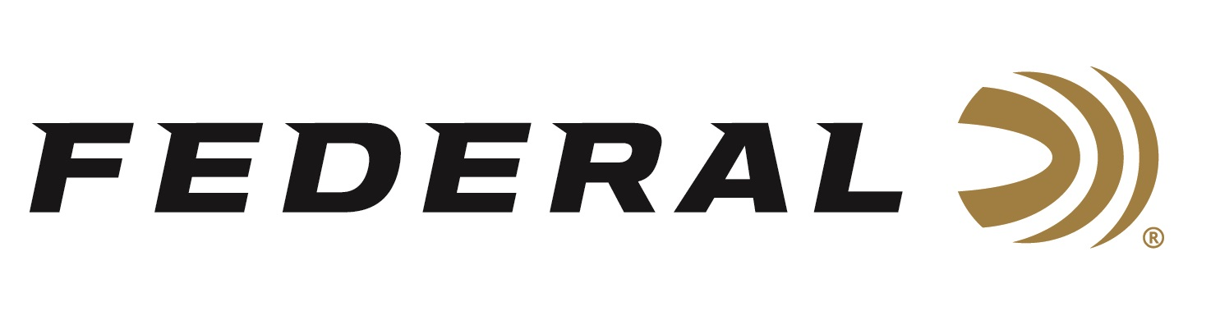

FOR IMMEDIATE RELEASE

Popular Federal Premium Barnes Triple-Shock X Loads Return

ANOKA, Minnesota – February 27, 2019 – Federal is bringing back its hard-hitting, exceptionally accurate Federal Premium Barnes Triple-Shock X rifle loads. Shipments have been delivered to dealers.

The immensely popular all-copper hollow point bullet groups tightly at long range and delivers consistent, lethal expansion. The monolithic design retains more than 99 percent of its weight on impact to penetrate deep, and its grooved shank minimizes barrel fouling and improves accuracy.

Features & Benefits
- One-piece copper construction
- Deep hollow-point tip
- Grooved bullet shank improves accuracy
- More than 99 percent weight retention
- Deep penetration and large, consistent expansion

Part No. / Description / MSRP
P223S / 223 Rem 55 grain Barnes TSX / $33.95
P224VLKBTSX1 / 224 Valkyrie 78 grain Barnes TSX / $35.95
P243K / 243 Win 85 grain Barnes TSX / $40.95
P2506H / 25-06 Rem 115 grain Barnes TSX / $43.95
P65CRDBTSX1 / 6.5 Creedmoor 130 grain Barnes TSX / $46.95
P270L / 270 Win 130 grain Barnes TSX / $46.95
P270WSMD / 270 WSM 130 grain Barnes TSX / $46.95
P708C / 7MM-08 Rem 140 grain Barnes TSX / $47.95
P308V / 308 Win 150 grain Barnes TSX / $45.95
P308H / 308 Win 165 grain Barnes TSX / $45.95
P3030G / 30-30 Win 150 grain Barnes TSX / $43.95
P3006AE / 30-06 Sprg 180 grain Barnes TSX / $46.95
P3006AF / 30-06 Sprg 165 grain Barnes TSX / $46.95
P7RN / 7MM Rem Mag 160 grain Barnes TSX / $48.95
P300WSMF / 300 WSM 180 grain Barnes TSX / $52.95
P300WSMG / 300 WSM 165 grain Barnes TSX / $52.95
P300WP / 300 Win Mag 180 grain Barnes TSX / $48.95
P300WR / 300 Win Mag 165 grain Barnes TSX / $48.95

For more information on Federal ammunition, visit www.federalpremium.com.

Press Release Contact: JJ Reich
Senior Communications Manager - Ammunition
E-mail: VistaPressroom@VistaOutdoor.com

About Federal Ammunition
Federal, headquartered in Anoka, MN, is a brand of Vista Outdoor Inc., an outdoor sports and recreation company. From humble beginnings nestled among the lakes and woods of Minnesota, Federal Ammunition has evolved into one of the world's largest producers of sporting ammunition. Beginning in 1922, founding president, Charles L. Horn, paved the way for our success. Today, Federal carries on Horn's vision for quality products and service with the next generation of outdoorsmen and women. We maintain our position as experts in the science of ammunition production. Every day we manufacture products to enhance our customers' shooting experience while partnering with the conservation organizations that protect and support our outdoor heritage. We offer thousands of options in our Federal Premium and Federal lines—it’s what makes us the most complete ammunition company in the business and provides our customers with a choice no matter their pursuit.

Federal is part of Vista Outdoor Inc., an outdoor sports and recreation corporation. For news and information on Vista Outdoor Inc., visit www.vistaoutdoor.com.

###

