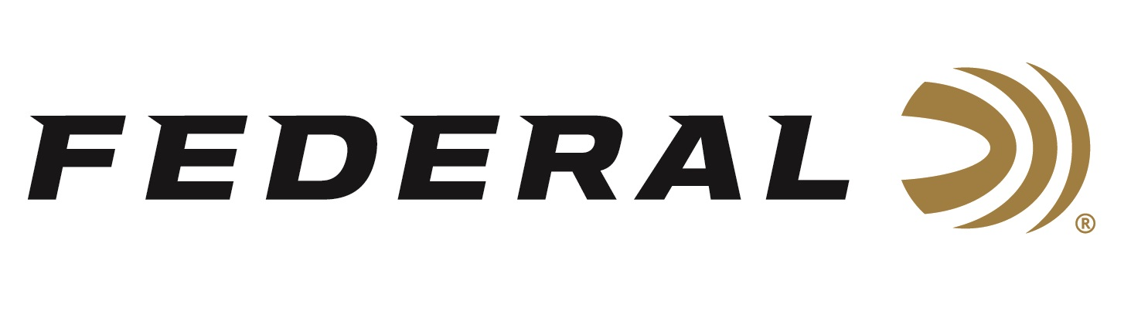

FOR IMMEDIATE RELEASE

Get Accuracy Through Any Rifle with Berger Hybrid Hunter Loads

ANOKA, Minnesota – March 15, 2019 – Federal unveils Federal Premium Berger Hybrid Hunter, loads that combine the profile of a low-drag match bullet and the terminal performance of a traditional hunting projectile for lethal accuracy at any range. Shipments have been delivered to dealers.

Berger Hybrid Hunter bullet weights have been fine-tuned to provide exceptional accuracy through any rifle. Ballistic coefficients exceed those of comparable designs thanks to a hybrid nose design that combines tangent and secant ogive features. The bullets are loaded with our finest nickel-plated brass, Gold Medal primers and specially formulated propellant for the best consistency and reliability.

Features & Benefits
- Hybrid tangent-secant ogive bullet design
- High ballistic coefficient
- Superior accuracy across a wide range of firearms
- Lethal and reliable terminal performance on medium and big game
- Loaded to tight specifications with Gold Medal primers, nickel-plated brass and specialized propellant

Part No. / Description / MSRP
P243BCH1 / 243 Win 95 grain Berger Hybrid Hunter / $37.95
P65CRDBCH1 / 6.5 Creedmoor 135 grain Berger Hybrid Hunter / $43.95
P270BCH1 / 270 Win 140 grain Berger Hybrid Hunter / $40.95
P270WSMBCH1 / 270 WSM 140 grain Berger Hybrid Hunter / $42.95
P7RBCH1 / 7mm Rem Mag 168 grain Berger Hybrid Hunter / $44.95
P280AIBCH1 / 280 Ackley Improved 168 grain Berger Hybrid Hunter / $45.95
P308BCH1 / 308 Win 168 grain Berger Hybrid Hunter / $42.95
P3006BCH1 / 30-06 Sprg 168 grain Berger Hybrid Hunter / $42.95
P300WBCH1 / 300 Win 185 grain Berger Hybrid Hunter / $49.95
P300WSMBCH1 / 300 WSM 185 grain Berger Hybrid Hunter / $49.95

For more information on Federal ammunition, visit www.federalpremium.com.

Press Release Contact: JJ Reich
Senior Communications Manager - Ammunition
E-mail: VistaPressroom@VistaOutdoor.com

About Federal Ammunition
Federal, headquartered in Anoka, MN, is a brand of Vista Outdoor Inc., an outdoor sports and recreation company. From humble beginnings nestled among the lakes and woods of Minnesota, Federal Ammunition has evolved into one of the world's largest producers of sporting ammunition. Beginning in 1922, founding president, Charles L. Horn, paved the way for our success. Today, Federal carries on Horn's vision for quality products and service with the next generation of outdoorsmen and women. We maintain our position as experts in the science of ammunition production. Every day we manufacture products to enhance our customers' shooting experience while partnering with the conservation organizations that protect and support our outdoor heritage. We offer thousands of options in our Federal Premium and Federal lines—it’s what makes us the most complete ammunition company in the business and provides our customers with a choice no matter their pursuit.

Federal is part of Vista Outdoor Inc., an outdoor sports and recreation corporation. For news and information on Vista Outdoor Inc., visit www.vistaoutdoor.com.

###

