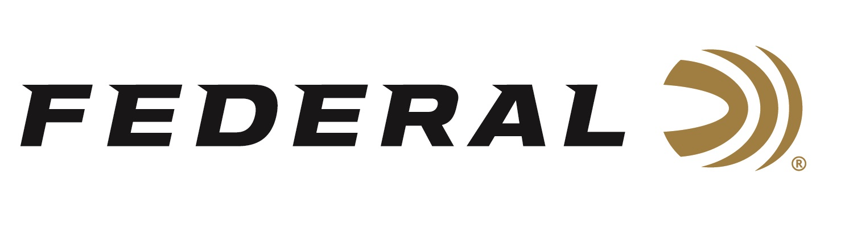

FOR IMMEDIATE RELEASE

Federal Premium Black Cloud TSS Hits Waterfowl Harder, Farther

ANOKA, Minnesota – April 15, 2019 – Federal introduces Federal Premium Black Cloud TSS waterfowl shells, which deliver hard-hitting performance on high-flying birds. These blended loads feature No. 7 or 9 TSS with BB or No. 3 FLITESTOPPER steel.
Shipments of Federal Premium Black Cloud TSS ammo have been delivered to dealers.

Black Cloud TSS carries on a lethal legacy, blending proven FLITESTOPPER Steel pellets and 18 g/cc Tungsten Super Shot. With 56 percent higher density than lead and more than double the density of steel, TSS pellets maintain velocity farther, hit harder and penetrate deeper than any waterfowl payload ever has. The swarm of shot leaves no chance for escape with the FLITECONTROL FLEX wad, which opens from the rear for a controlled release of the payload and the deadliest, most consistent patterns.

Features & Benefits
- Extends effective range past 50 yards
- 60 percent HEAVYWEIGHT TSS pellets
- TSS is more than double the density of steel and 56 percent denser than lead
- 40 percent FLITESTOPPER Steel
- FLITECONTROL FLEX wad provides the most consistent patterns in all waterfowl chokes
- Lead-free Catalyst primer and clean, fast-burning propellant
- Blended loads featuring No. 7 or 9 TSS with BB or No. 3 FLITESTOPPER steel

Part No. / Description / MSRP
PWBTSSX142 7BB / 12-gauge, 3-inch, 1 ¼-ounce BB FS Steel/No. 7 TSS, 1450 fps / $37.95
PWBTSSX142 39 / 12-gauge, 3-inch, 1 ¼-ounce No. 3 FS Steel/No. 9 TSS, 1450 fps / $37.95

For more information on Federal ammunition, visit www.federalpremium.com.

Press Release Contact: JJ Reich
Senior Communications Manager - Ammunition
E-mail: VistaPressroom@VistaOutdoor.com

About Federal Ammunition
Federal, headquartered in Anoka, MN, is a brand of Vista Outdoor Inc., an outdoor sports and recreation company. From humble beginnings nestled among the lakes and woods of Minnesota, Federal Ammunition has evolved into one of the world's largest producers of sporting ammunition. Beginning in 1922, founding president, Charles L. Horn, paved the way for our success. Today, Federal carries on Horn's vision for quality products and service with the next generation of outdoorsmen and women. We maintain our position as experts in the science of ammunition production. Every day we manufacture products to enhance our customers' shooting experience while partnering with the conservation organizations that protect and support our outdoor heritage. We offer thousands of options in our Federal Premium and Federal lines—it’s what makes us the most complete ammunition company in the business and provides our customers with a choice no matter their pursuit.

Federal is part of Vista Outdoor Inc., an outdoor sports and recreation corporation. For news and information on Vista Outdoor Inc., visit www.vistaoutdoor.com.

###

