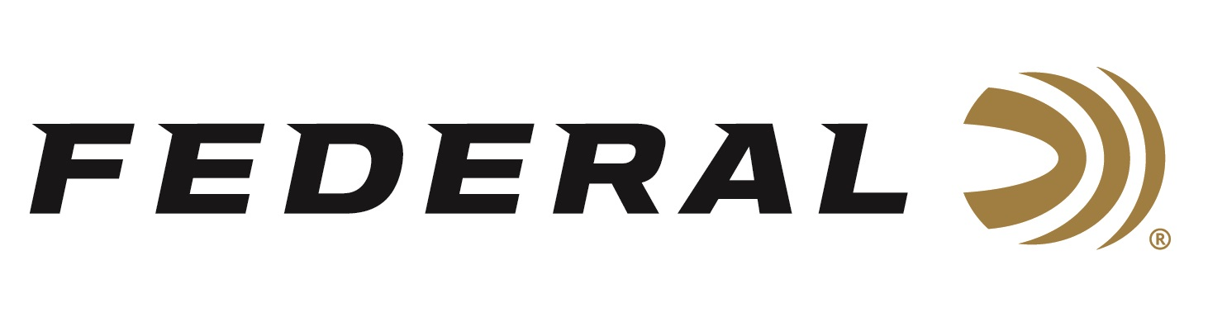

FOR IMMEDIATE RELEASE

Gold Medal Grand Plastic Loads Boost Performance on Clays

ANOKA, Minnesota – March 27, 2019 – Federal is broadening its Federal Premium Gold Medal Grand Plastic target shotshell line, offering competition clays shooters a whole new performance standard. Shipments have been delivered to dealers.

Gold Medal Grand Plastic delivers less felt recoil, more reliable ignition, improved shot hardness and excellent reloadability. Now there are even more options in the product line, with two new 24-gram international loads. Both feature the rigid PrimerLock head to improve primer sensitivity, SoftCell wad technology to cut felt recoil, and lead shot engineered to provide the optimum blend of hardness and density. The result is the most powerful and consistent patterns trusted by the world’s best shooters.

Features & Benefits
- 24-gram payload
- Two-piece wad utilizes SoftCell technology to decrease perceived recoil and produce more uniform patterns than one-piece designs
- Rigid PrimerLock head improves primer sensitivity, ensuring proper ignition in the event of a light hit
- Lead shot is engineered for the optimum blend of hardness and density for even patterns and maximum downrange power
- Integral base wad maximizes reloadability

Part No. / Description / MSRP
GMT119 7.5 / 12 gauge 2 ¾ inch 24 gram, 7.5, 1,335 fps 25-count / $11.95
GMT119 9 / 12 gauge 2 ¾ inch 24 gram, 9, 1,335 fps 25-count / $11.95

For more information on Federal ammunition, visit www.federalpremium.com.

Press Release Contact: JJ Reich
Senior Communications Manager - Ammunition
E-mail: VistaPressroom@VistaOutdoor.com

About Federal Ammunition
Federal, headquartered in Anoka, MN, is a brand of Vista Outdoor Inc., an outdoor sports and recreation company. From humble beginnings nestled among the lakes and woods of Minnesota, Federal Ammunition has evolved into one of the world's largest producers of sporting ammunition. Beginning in 1922, founding president, Charles L. Horn, paved the way for our success. Today, Federal carries on Horn's vision for quality products and service with the next generation of outdoorsmen and women. We maintain our position as experts in the science of ammunition production. Every day we manufacture products to enhance our customers' shooting experience while partnering with the conservation organizations that protect and support our outdoor heritage. We offer thousands of options in our Federal Premium and Federal lines—it’s what makes us the most complete ammunition company in the business and provides our customers with a choice no matter their pursuit.

Federal is part of Vista Outdoor Inc., an outdoor sports and recreation corporation. For news and information on Vista Outdoor Inc., visit www.vistaoutdoor.com.

###

